RACEWALKING AND THE OLYMPICS

A brief history of Racewalking in the Olympic Arena

With special mention of the Victorian based walkers who helped form that history

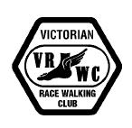

Victorian Race Walking Club

2003

TABLE OF CONTENTS

RACEWALKING AND THE OLYMPICS 1

INTRODUCTION 3

The start of the modern Olympic Movement 4

1906 – THE FIRST OLYMPIC WALKS, ATHENS 4
1908 LONDON 6
1912 Stockholm 8
1920 Antwerp 10
1924 Paris 12
1928 AMSTERDAM 14
1932 Los Angeles 15
1936 Berlin 16
THE WAR YEARS – LOST OPPORTUNITIES 18
1948 London 19
1952 Helsinki 22
1956 Melbourne 25
1960 Rome 28
1964 Tokyo 31
1968 Mexico City 34
1972 Munich 37
1976 Montreal 39
1980 Moscow 41
1984 Los Angeles 44
1988 Soeul 48
1992 Barcelona 52
1996 Atlanta 58
2000 Sydney 62

THE VICTORIAN ROLL OF HONOUR 67

OLYMPIC STATISTICS 68

REFERENCES 69

INTRODUCTION

Racewalking has had a chequered Olympic history. Its inception in the 1906 Games was controversial. It was thrown out after the debacles of 1924, fought its way back in 1932, was changed from track to longer road events because of judging problems, was partially removed in 1976 but came back from the dead. Even after the 2000 Olympics, it was told in no uncertain terms to get its act into gear if it wished to keep its place in the Olympics.

So little has changed in nearly 100 years! Racewalking continues to be a sport that attracts either love or hate – there seems to be little middle ground. But for those who love the sport and have enjoyed a long association with it, it is a wonderful discipline that attracts more than its fair share of characters and wonderful athletes.

The first Australian walker to compete at Olympic level was Victorian Bill Murray in 1912. Since then, Victoria has had a wonderful participation rate with a total of 18 Victorian based walkers competing in this ultimate sporting event. The roll of honour includes most of the top names from Australian racewalking history.

Bill Murray (dec.) 1912
George Knott (dec.) 1948
Don Keane 1952, 1956
Norm Read (dec.) 1956
Ray Smith 1956
Noel Freeman 1960, 1964
Bob Gardiner 1964, 1968, 1972
Ted Allsopp 1956, 1964
Ross Haywood 1976
Willi Sawall 1980, 1984
David Smith 1980, 1984
Michael Harvey 1984
Andrew Jachno 1984, 1988, 1992
Simon Baker 1984, 1988, 1992, 1996
Gabrielle Nelson (Blythe) 1992
Dion Russell 1996, 2000
Duane Cousins 1996, 2000
Nathan Deakes 2000

This is an almost entirely male domain with Gabrielle Nelson (Blythe) being the only female representative. Many of the walkers have represented at more than one Olympic Games and most have represented Australia on other occasions at Commonwealth Games, IAAF World Championships, Racewalking World Cups, World Indoor Championships, World Junior Championships and more.

Although there are the occasional dream-come-true stories of outsiders winning Gold, the Olympic walk is normally won by the favourite. It is the top walker with proven credentials who can produce the winning performances when required. The history of Olympic racewalking is a history of champions who win as expected.

I wish you all a pleasant read.

Tim Erickson
Secretary, Victorian Race Walking Club

9 November 2003

The start of the modern Olympic Movement

The first modern Olympics in Athens in 1896 were a small affair by modern standards. The only sports contested were athletics, cycling, fencing, gymnastics, lawn tennis, shooting, swimming, weight lifting and wrestling and a scant 13 nations sent unofficial teams to compete. The athletics component included 5 track events, 6 field events and a marathon run. Walking, although a popular sport at the time, was not included in the athletic program. Less than 500 competitors in total contested the various events.

Further Olympic celebrations were held in Paris in 1900 and St Louis in 1904, each in conjunction with International Exhibitions hosted in those cities. Alas, walking was still on the outer.

1906 – THE FIRST OLYMPIC WALKS, ATHENS

It was not until 1906 that walking was finally included on the Olympic stage in a Games which has become known as The Interim Olympic Games. Greece had lobbied that the Games be kept permanently in Athens after 1896 but the 2 subsequent Games had been awarded to other cities. The Greeks obtained permission from the IOC to stage a Games in Athens on the tenth anniversary of their revival. They planned that there should be a Games in Athens every 10 years but the 1906 venture was in fact unique.

These Games were the first modern Olympic Games and were run as a standalone event of international standing. The athletics program was increased to 24 events and 2 racewalks were included.

The first of these events was a 1500m track walk. Richard Wilkinson of England and Eugen Spiegler of Austria finished first and second but were disqualified for illegal technique. This left the American George Bonhag with first place, although he too was disqualified by two of the four judges. The deciding vote in favor of Bonhag was cast by the president of the jury, Prince George. Bonhag had actually never entered a walking race before. Disappointed by his showings in the 5-mile run and the 1500-meter run in which he had finished fourth and sixth, Bonhag entered the 1500-meter walk hoping to make up for his previous failures. He was rewarded with the Gold medal.

- George Bonhag USA 7:12.6
- Donald Linden CAN 7:19.8
- Konstantin Spetsiotis GRE 7:24.0
- Georgios Saridakis GRE -
- Harilaos Vasilakos GRE -
- Alexandros Kouris GRE -
- Gybrgy Sztantics HUN -
Richard Wilkinson GBR DQ
Eugen Spiegler AUT DQ

The day after the controversial 1500-meter walk, a second contest was held over 3000 meters. Once again Wilkinson and Spiegler moved to the front. Fifty meters from the finish, they both began to run and were again disqualified.

- Gybrgy Sztantics GER 15:20.0
- Georgios Saridakis GRE 15:33.0
- Pandebs Ektoros GRE -
- Panagoulopoulos GRE -
Richard Wilkinson GBR DQ
Eugen Spiegler AUT DQ
Konstantin Spetsiotis GRE DQ

How were these early walks judged? For its inaugural Championship Meeting in 1880 in London, the A.A.A. published its first Rules for Competition. Of the 16 rules promulgated, 3 were of relevance to walking

- In Walking Races, cautions and disqualifications to be left to the discretion of the Judges.

- The decisions of the Judges in each competition to be final.

- All cases of disputes and any questions that may arise, not provided for in these rules, or the interpretation of any of these rules, to be referred to the Committee of Management at the time, whose decision shall be final.

The judge’s interpretation was based on a concept of ‘fair heel and toe’ but what is fair to one judge may not be fair to another. Personality and nationality were always going to be factors.

With such loose guidance, it was inevitable that the early attempts to judge the walks at the Olympics should be dogged by controversy.

1908 LONDON

After such a inauspicious start, it was perhaps surprising that walking continued in the Games. But it had friends in high places and England was the most powerful walking nation in the world. There was no way that walks were not going to be included in the 1908 London Games.

George Larner, a 33-year-old Brighton policeman, came out of retirement to take part in the Olympics. He won the 3000m walk by 45 yards and then backed up and won the 10 mile walk. Both events were held on the track.

Men 3500m. Walk

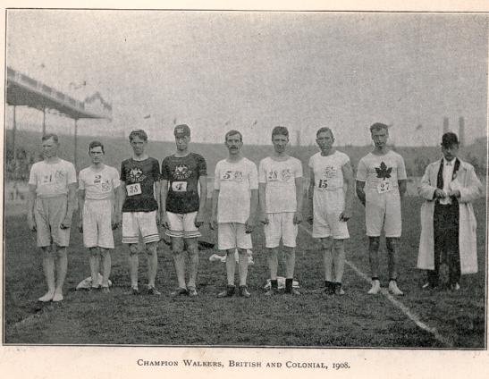
The 3500m walk was held first and such was the level of interest that 3 heats of 8 were held, with the first 3 from each heat going through to the final. Larner, Webb and Goulding each won his heat with Webb the fastest qualifier in 15:17. Since Goulding was an English born walker representing his adopted country of Canada, the English could claim to have the top 3 walkers in the event and an exciting final was expected.

The start of the 1908 Olympic 3500m walk. George Larner is fifth from the left.

It was Larner who turned the tables on Webb and won the final by 45 yards. Harry Kerr, the champion New Zealand walker, representing Australasia, beat Goulding for the bronze medal.

- George LARNER GBR 14.55.0
- Ernest WEBB GBR 15.07.4
- Harry KERR NZL 15.43.4
- George GOULDING CAN 15.49.8
- Arthur ROWLAND NZL 16.07.0
- Charles WESTERGAARD DEN 17.21.8
- Einar ROTHMAN SWE 17.50.0
William PALMER GBR DNF
Richard HARRISON GBR DQ

Men 10mile Walk

The 10 Mile walk was also held on the track and saw 2 heats of 12 and 13 competitors respectively with the first 4 from each heat to contest the final. Larner and Webb each won his heat with Larner the fastest qualifier in 1:18:19.

In the final, Larner was again too good for the rest, breaking the 11 year-old world amateur record of 1:17:38.4 in winning his second gold medal in four days. But his time was still over a minute outside the world professional record of 1:14:45.0, held by J. W. Raby.

- George LARNER GBR 1.15.57.4
- Ernest WEBB GBR 1.17.31.0
- Edward SPENCER GBR 1.21.20.2
- Frank CARTER GBR 1.21.20.2
- Ernest LARNER GBR 1.24.26.2
William PALMER GBR DNF
Richard HARRISON GBR DNF
Harry KERR NZL DNF

These Games were notable for the impeccable styles of the leading walkers. There could be no doubts about the styles of Larner and Webb who were deemed by all to be outstanding exponents of the art of walking.
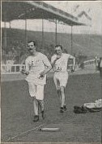

Larner leads Webb in the 3500m walk

1912 Stockholm

These Olympics surpassed previous promotions in organisation, participation and performance. Held with typical Scandinavian flair in the Swedish Capital, the Games attracted 2,484 men and 57 women competitors who participated in a program that included no fewer than 18 shooting events, 3 gymnastics team events and indoor and outdoor tennis. Women’s swimming was included for the first time and the new sport of modern pentathlon - which was designed to find the best all round athlete in the world – was added.

In Stockholm, only 1 walk was contested, over a distance of 10,000 metres.

Men 10,000m Walk

Once again, the level of interest in the walk meant that 2 heats had to be contested. Of the 25 walkers, the first 5 in each heat would progress to the final.

George Goulding, an English-born Canadian, had competed in the 1908 Olympics as both a walker and a runner, placing 4th in the 3500 meter walk and 22nd in the marathon. In 1932, he made the walk his main event and was the fastest qualifier in 47:14. Ernest Webb was second fastest with 47:25, well outside his own World Record of 45:15.6.

In the final, Goulding kept up such a rapid pace that three of the ten finalists dropped out and another three were disqualified for lifting. This should have acted as a warning that there were dangers to walking as an Olympic event but it went unheeded.

After his victory, the laconic Canadian sent a telegram to his wife that read simply, "Won-George."

Ernest Webb, who earned his third Olympic silver medal, was 40 years old.

- George GOULDING CAN 46.28.4
- Ernest WEBB GBR 46.50.4
- Fernando ALTIMANI ITA 47.37.6
- Aage RASMUSSEN DEN 48.00.0
KAISER USA DNF
William PALMER GBR DNF
GYLCHE DEN DNF
DUMBILL GBR DQ
YATES GBR DQ
NORMAN RSA DQ

William MURRAY AUS DQ in heat

This Olympics saw the first Australian racewalking participant in Bill Murray from Melbourne. George Kerr had represented Australasia in 1908 but he was a New Zealander.

Bill Murray, born in 1882, was an incredible talent by any measure. Joining the Melbourne Harriers as a young man, he quickly developed into a top class runner. His best performance was held to be in the 1910 seven mile open race at Brighton where he secured first and fastest time prizes with 36:21. There was a big field of 108 competitors, including E. Voight, fresh from Olympic and world championships triumphs.

In that same year, he also won the Victorian 10 mile track race and is credited as winning the first marathon run in Melbourne. This event ran from Frankston to Melbourne and he won in 2:58:48. This remained the best marathon time by a Victorian until it was beaten by Percy Cerrutty 36 years later (when he won the 1946 Victorian marathon in 2:58:11).

His debut as a walker came when he was asked to take part in a race to fill a poor field. To his amazement and the delight of his club, he won. Two weeks later he walked in two races in Melbourne and beat Australian record holder A. O. Barrett.

His walking really came to the attention of the public in 1911 with his wins in the Victorian 1 mile (6:40.8) and 3 mile (22:38.6) walk events. His 1 mile time was a new Victorian and Australasian record, beating Barrett’s 1896 time of 6:42.0. The next year, he was even faster, winning the titles once again with records that the general sporting population could hardly credit – his 1 mile time was 6:22.8 and his 3 mile time was 20:56.0.
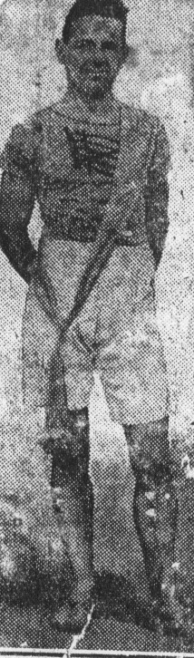

Bill Murray in 1912 – Australasian record holder

The rumpus was soon on. The chairman of the Austalian Amateur Athletic Union, Mr Richard Coombes, said “No man in the world can walk that fast.” And others joined the chorus.

But Bill was strongly supported by A. O. Barrett, whose records he had just broken. Barrett was the founder of the Melbourne Amateur Walking and Touring Club (1884) and was a highly regarded official at this time. He actually judged in the 1912 races and had this to say about the performances:

It was my pleasure to judge the Amateur Championships held on the St. Kilda Cricket Ground on 24th February, 1912, when W. Murray broke my records in the 1 mile and 3 miles Championships of Victoria, and set fresh records for Australasia.

The day was sunny, no wind, and cool. In both those races he walked absolutely faultlessly, and the cheers of the spectators during the last laps must have been as gratifying to him as it was to all of us in the official part of the arena, and only proves what a valuable and noble contest a walking race is in our sports when it is exemplified by a properly trained athlete,

The new records he created were one mile in 6 min. 22.8 see., and later on the same afternoon he walked the three miles in 20 min. 56 sec. For these details I am indebted to the Hon. Sec. of the V.A.A.A., Mr. F. H. Pizzey.

These 2 performances were so ahead of their time that they withstood all challenges over the next 36 years. When the last Victorian 1 mile and 3 mile walk championships were held in 1948, they still stood as championship records. George Knott walked 21:29.0 to win the 3 mile in 1940 and walked 6:23.2 to win the 1 mile in 1948 –close to but not as good as Bill’s 1912 performances.

On the basis of his outstanding walks, he was selected to compete for Australasia in the 1912 Olympics. History shows that he was disqualified but there is more to the story as he elaborated in later years

The Australian team struggled from the time it landed in Europe. We had to fend for ourselves and were not properly fit. We were not there long enough to become fit. There were no Olympic Villages. You had to find your own accomodation and eat in cafes.

Once he returned from the Olympics, he put the disappointment behind him and continued his local athletics career for many years.

1920 Antwerp

These Games were the first stumbling attempts at a global get-together in a world recently shattered. The Olympic flag was unfurled for the first time and the Olympic oath was introduced. The disappointingly sparce attendances betrayed the haste with which the Games had been organised. Belgium had only been given one year’s notice in which to prepare and her war-weary people was not in the mood to attend.

Belgium did not invite any of the Central powers – Austria, Bulgaria, Germany, Hungary or Turkey – so the Games could hardly be called a World gathering. Only 29 counties attended.

This Games saw the emergence of one of the greatest Olympic walkers of all time. Italian Ugo Grigerio won both Gold medals in Antwerp, won Gold again in 1924 and won bronze in 1932.

Frigerio was such a colourful character that his flamboyance often obscured the fact that he was a superb athlete who combined great speed with perfect style. While other walkers became nervous or annoyed when a judge got down on his hands and knees to scrutinize their style, he seemed to enjoy the attention, and always made it a point to thank the judge when he was finished. He also enjoyed the attentions of the crowd, sometimes taking the time to exchange re-marks with spectators, and even leading cheers for himself.

Men 3000m Walk

Two heats of 11 were held with the first 6 walkers from each heat progressing to the final. Italians Frigerio (13:40) and Pavesi (13:46) won the heats and the stage seemed set for an all Italian battle in the final. The biggest discussion was the disqualification of World Record holder Gunnar Rasmussen of Denmark in the second heat. With his World Record standing at 12:53.8, he had been disqualified while walking about 1 minute slower. Such is the nature of walking!

Just before the beginning of the final, Frigerio approached the conductor of the band in the middle of the field and handed him several pages of sheet music that he requested to be played during the course of the race. Accompanied by the proper background music, he moved quickly to the front and led the entire race pausing only once toward the end to admonish the band for not playing at the correct tempo. He won easily by 20 meters. Pavesi was the only disqualification in the final.

The big news for Australia was the second place by NSW walker George Parker. It was a battle between youngsters as Frigerio was aged 19 and Parker aged 20.
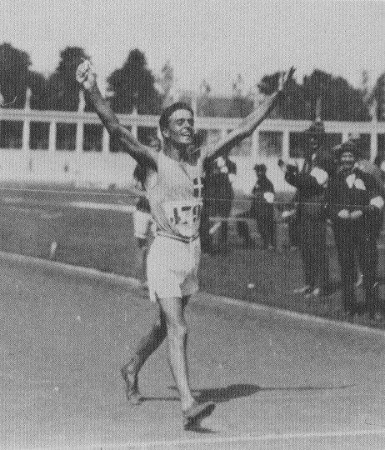

Musically minded Ugo Frigerio won a total of 3 walking gold medals in 1930 and 1924

- Ugo FRIGERIO ITA 13.14.2 OR
- George PARKER AUS 13.19.6
- Richard REMER USA 13.22.2
- Cecil McMASTER SAF 13.23.6
- Thomas MARONEY USA 13.25.0
- Charles DOWSON GBR 13.28.0
- William HEHIR GBR 13.29.8
- William ROELKER USA 13.30.4
Jean SEGHERS BEL -
Charles GUNN GBR -
Niels PEDERSEN DEN -
Donato PAVESI ITA DQ

Men 10,000m Walk

Once again, heats were necessary to grade the 23 entrants with the top 6 from each heat progressing to the final. As in the previous race, World Record holder Rasmussen (45:26.4) was disqualified and this left Frigerio a clear favourite after his slick time of 47:06. NSW walker George Parker finished 3rd in the same heat in 47:31.

The final was a boilover with Frigerio, as boisterous as ever, winning by 250 meters. Parker failed to finish while Pavesi was once again disqualified.

- Ugo FRIGERIO ITA 48.06.2
- Joseph PEARMAN USA 49.40.2
- Charles GUNN GBR 49.43.90
- Cecil McMASTER SAF 50.04.0
- William HEHIR GBR 50.11.8
- Thomas MARONEY USA 50.24.4
- Jean SEGHERS BEL 50.32.4
- Antoine DOYEN BEL 56.30.0
George PARKER AUST DNF
CARDENAS ESP DNF
PLANT USA DNF
Donato PAVESI TA DQ

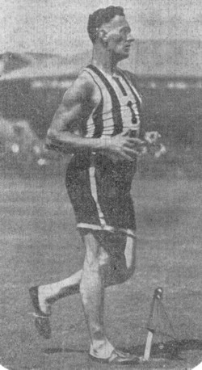
Australia’s representative, George Parker of NSW, was a talented all rounder who was equally adept at walking, distance running, high jumping or throwing. At 6 feet in height and weighing in at 12 stone 10 lbs when fully fit, he physically intimidated his rivals and could have excelled at most sports. He only took up racewalking in 1918 and comfortable wins in the 1920 Australian 1 mile and 3 mile walk championships gained him his Olympic selection. In Antwerp he fulfilled his promise and took Olympic silver, only 5 seconds in arrears of Frigerio.

George Parker, a physically intimidating walker at 6 feet in height and nearly 13 stone in weight.

On returning to Australia, he retired from athletics and did not return to the sport until after the 1924 Olympics. At that stage in late 1924 and early 1925, he went on a record breaking spree, setting the Australian record books alive with his performances. But with the walks removed from the 1928 Olympics, he had nothing really to aim for and he eventually retired once again.

1924 Paris

The second Olympics to be held in Paris were in great contrast with the chaotic 1900 Games. 1924 was an extended sporting festival starting with the first Winter Olympics in January in Chamonix followed by rugby and association football competitions and culminating with the Summer Olympics in July.

Only 1 walk was scheduled for these Olympics. It was a time when walking lacked any real high profile champions and Rasmussen’s 10,000m record had withstood all challenges for a number of years.

The frequent disqualifications in the previous shorter distance walks had led to the retention of only 1 walk, over 10,000m on the track. It kept those interested in walking and those who would not normally have bothered with walking, in a turmoil of excitement right through.

Men 10km Walk

With 23 entrants, 2 heats were held with the first 5 from each heat progressing to the final. British walker Gordon Godwin was the fastest qualifier in 49:00, just ahead of Pavesi (49:09) and Frigerio (29:16). But the heats were controversial with doubt over the judging fairness.

Australian Ernie Austen, from NSW, had hoped to do well but was astonished when he was disqualified in the early stages of the first heat. He was warned in the first lap by the French judge who thought his gait doubtful. In the second lap the American judge ordered him off when he was lying third and was doing well. In later years, he commented

“I was in third place, just behind the leaders and going along very easily. I thought I had a good chance but then an American judge came up and told me I was disqualified. I asked him why but he said he didn't know. You usually get two cautions before being disqualified but I wasn't aware of them. Nobody ever did tell me why I was outed."
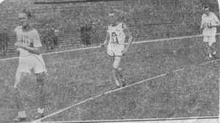
Ernie Austin, in the middle, before being disqualified in the 1924 Olympic 10,000m walk

He broke down and went to the dressing rooms. It was his first disqualification in some 15 years of competitive walking and he was regarded in Australia as a perfect stylist. The pace at the time of his disqualification was very slow – equal to about 7:30 to the mile. Australian officials were adamant that his style was satisfactory and the whole event deteriorated into an ugly affair.

That was not the only controversy. When Austrian Kuhnel was disqualified, also in the first heat, an appeal was made to the jury on the ground that he did not speak the language of the judges who had disqualfied him and that he did not understand the warnings they had given him. The jury agreed with the walker, overruled the judges and ordered that the Austrian should compete in the second heat. The result was obvious. The panel of judges reisgned and a new one had to be found before the event could go on.

It was Frigerio who won the final easily by some 200m. But the damage was done. Walking had lost its credibility and was subsequently dropped from the 1928 Olympics.

- Ugo FRIGERIO ITA 47.49.0
- Gordon GOODWIN GBR 48.37.9
- Cecil McMASTER SAF 49.08.0
- Donato PAVESI ITA 49.17.0
- Arthur Tell SCHWAB SWI 49.50.0
- F. Ernest CLARKE GBR 49.59.2
Armando VALENTE ITA -
BOSATRA ITA -
Ernie AUSTEN AUS DQ in heat

1928 AMSTERDAM

With the controversies of the 1924 Olympic walks, the future of walking as an Olympic sport was again in question. At the next Congress of the International A A. Federation, held in the Hague, it was decided to exclude walking from the Olympic programme, by one vote – 9 to 8.

The motion to include a walk over 5000 metres, and in one race, without heats, was made by U.S.A. and Australasia (Australia and New Zealand) and supported by Great Britain which preferred a 10,000 metres event but would be satisfied by one of 5000 metres.

Italy strongly supported the motion, whilst Norway, Sweden, Roumania, Finland and France were against it, the French representative expressing the hope, in view of the difficulties experienced by judges at former Games, “That the event would be omitted for ever from the programme of the Olympiad.”

The voting was:

For the walk: Australasia, Germany, Great Britain, Holland, Ireland, Italy, South Africa and U.S.A.
Against: Austria, Finland, France, Germany, Hungary, Norway, Roumania, Sweden and Switzerland.
Abstaining: Belgium and Poland.

1932 Los Angeles

Controversies in the 1924 Olympic Games had spelt an end to Olympic track walking and indeed nearly spelt the end of walking. The sport was ruled out of the 1928 Amsterdam Games. Fortunately, there followed a change in walking fashion with road walking overtaking track walking in popularity and British officials worked together and bid for a long distance road event to be introduced into the Olympics. It was accepted and the first Olympic road walk, over 50 kilometres, was announced for the Los Angeles Games in 1932.

Tommy Green, at 39 years of age, was the obvious choice to represent Great Britain. A railway worker, he held every British long distance record possible, had been unbeatable for some 3 to 4 years over the classics like the London to Brighton, and had won the British R.W.A. 50 km championship in 1931 in a world road best time of 4:35:36. The World Record of 4:34:03 had been set in 1924 by Paul Sievert of Germany, but he was now past his prime and not expected to feature in the medals.

The only question on Green was how a 39 year old would survive a five hour race in the heat of California? He let others make the pace, yet stayed among the leaders until the three quarter mark when the sun got to him and he lost a minute. Just when it seemed he had relinquished the race, a cold sponge revived him and he zipped through the field to win by over 7 minutes.

His historic win (he remains the oldest racewalking gold medallist) was in a slow time in what was described as ‘tropical conditions’ but he convincingly beat the best walkers of his day.
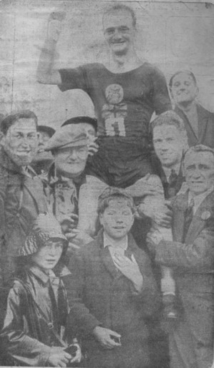

Tommy Green is hoisted shoulder high after winning his third successive London to Brighton in 1931. He covered the 52 miles in 8 hrs 5 mins 43 secs.

Ugo Frigerio added a bronze medal to the three golds he had won in 1920 and 1924. He had retired after 1924 but had come back specifically for this competition and had moved up to the 50 km, showing great versatility for someone who had been a specialist track walker.

Men 50km Walk

- Thomas GREEN GBR 4.50.10
- Janis DALINS LAT 4.57.20
- Ugo FRIGERIO ITA 4.59.06
- Karl HAHNEL GER 5.06.06
- Ettore RIVOLTA ITA 5.07.39
- Paul SIEVERT GER 5.16.41
- Henri QUINTRIC FRA 5.27.25
- Ernest CROSBIE USA 5.28.02

1936 Berlin

Hitler, aware of the immense propaganda value, made sure that the 1936 Olympics were the best organised and the most efficiently equipped Games ever. A huge 100,000 seat stadium was constructed and a luxurious Olympic village was built to house 4,000 competitors. There were 130 gold medals to be won in 19 sports.

33 walkers contested the single racewalking event, held over 50 km.

Men 50km Walk

English walker Harold Whitlock had come into prominence in 1932 with a record breaking win in the Hastings to Brighton walk. From then on, he was virtually unbeatable until the outbreak of the Second World War put paid to his career.

The 1936 British R.W.A. 50 km title was held on July 4 in Derby and was the official trial for the Berlin Games. In a race of great depth, Whitlock won in a world best time of 4:30:38, Hopkins was second in 4:31:01 and Bentley was third in 4:33:32. Defending Olympic champion Green was relegated to 4th place even though his finishing time would have won all previous editions of this event. Such was the depth of England walking at that time.

The Olympics soon came around and one can imagine the excitement for the young London mechanic as he entered the heady and controversial Berlin Games atmosphere. The Opening Ceremony was held before a crowd of 120,000 in the Olympic Stadium on July 30.

A few days later, in a memorable 50 km race over the streets of inner Berlin, it was Whitlock who triumphed.

He was actually the last walker to leave the stadium, but by pacing himself judiciously, he had overtaken everyone by 35 km. Then at 38 km – the same point where Green’s crisis had occurred – he had a bout of sickness and the pack began to close. Like Green, he recovered to finish strongly, thus winning Britain’s only individual gold medal in those Olympics. His time of 4:30:41 was a new Olympic record and was only 3 seconds outside his best time, recorded just a month earlier. His performance was even more meritorious considering that he had to battle stormy windy weather and rough cobblestoned roads (so rough that the British committee considered protesting).
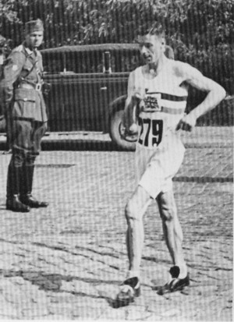

Whitlock strides over the cobblestones to victory in the Berlin 50 km even while a Nazi soldier looks on.

History records the first 8 places as follows

- Harold WHITLOCK GBR 4.30.41.4 OR
- Arthur SCHWAB SWI 4.32.09.2
- Adalberts BUBENKO LAT 4.32.42.2
- Jaroslav STORK CZE 4.34.00.2
- Edgar BRUUN NOR 4.34.53.2
- Fritz BLEIWEISS GER 4.36.48.4
- Karl REINIGER SWI 4.40.45.0
- Etienne LAISNE FRA 4.41.40.0

Schwab became a famous name in Olympic racewalking but for the wrong reasons. Skip ahead to the 1952 Olympics if you can’t wait to find out why!

THE WAR YEARS – LOST OPPORTUNITIES

The 1940 Olympics had been awarded to Tokyo but, when Japan and China went to war in 1938, the city withdrew as host. There then began an incredible period in which the IOC became the ostrich of the sports world and refused to believe what it was seeing.

Feeling it should stay out of world politics, the Games were moved to Helsinki, Finland. Even when the Russians invaded Finland, the IOC still continued with their planning. It was not until the Finnish Olympic Committee formally withdrew as host in April 1940 that the IOC finally shelved plans for any Games that year.

In the midst of this shuffling, the IOC awarded the 1944 Games to London. With World War Two still raging, these Games were also eventually called off.

So from 1936 to 1948, no Olympic Games were held. Harold Whitlock was not given the chance to defend his Olympic 50 km title. The Swedish walkers, who were starting to dominate the world scene, were not given the chance to test their mettle in the ultimate sporting arena.

The best Australian walkers of the time were similarly effected. It is worthwhile mentioning a number who might have competed in the Olympics during this period if war had not intervened.

The first two walkers were up and coming short distance walkers. One was NSW based and one was Victorian based. They were both speedsters of the first rank and both had the competitive instincts of the true champion.

Athol Stubbs was the dominant Australian track walker in the late 1930’s. He twice created World Best Track performances for 1 mile (6:18.2 in Sydney on 25 February 1939 and 6:15.4 in Sydney on 17 February 1940) and was the reigning Australian 1 mile track, 3 mile track and 10,000m road champion at the outbreak of war. When championships were finally restarted in 1947, he again resumed his winning ways and took the 1947 Australian 3 mile track title. Although he remained competitive on the national arena until the early 1950s, he never fully regained his pre-war form and had missed out on his chance to shine on the world arena.

George Knott was only narrowly beaten by Athol Stubbs in the 1939 Australian 10,000m walk championship and had won the 1940 Victorian 1 mile and 3 mile titles in times just outside Bill Murray’s old records. He was the young gun on the rise but had to wait until 1948 for his Olympic chance.

The next two walkers were amongst the many stong 50 km walkers of the time. Again, one was Victorian and one was from NSW. Both were as tough as old boots and thrived on the challenge of a long race.

Jim Gaylor was a product of the depression, left home at 15, slept rough in the backstreets of Richmond and lived as best he could while he pursued his walking. His first really major success was in the VAWC 50 mile championship at the Showgrounds in October 1931. The event had been put on the track to allow Jack Lewis to attack his various State records and Jim had been talked into participating simply to help Jack. But it was Jim who won the event and set new Victorian records for all distances from 15 miles to 50 miles. His 50 mile time of 8:49:33 beat the Lewis’s State record by a massive 32 mins. From then one, he was a regular Victorian State champion over the long distances. He won Victorian 50 km titles in 1933 and in 1937, 1938 and 1939. Any thoughts of Olympic selection were dashed when Australia entered the Second World War and the 1940 Olympics were cancelled. War was announced the day after his 1939 Victorian 50 km title win, his fifth. Wounded on numerous occasions in an illustrious war career, he returned to Australia and resumed his career in 1946 but, like Stubbs, had missed his chance. For many athletes, the opportunity comes only once.

Gordon Smith, born 18 January 1902 in Burwood in NSW, was one of the most consistent competitors in NSW for a long period from the early 1920’s right up to the outbreak of war. Winning his first State Championship medal at 20 years of age, his 17 year career saw him accumulate 17 Gold and 5 Silver Medals in NSW State Championships, a silver in the 1935 Australian 50 km championship and a swag of State and Australasian records for distances from 15 miles upwards. With such a background, it was not surprising that he would one day try for longer distances if the opportunity presented. This happened in 1937 when he completed a 24 hour walk and in 1938 when he completed both a 12 hour and a 24 walk in the space of 1 month. His 12 hour distance of 65 miles 781 yards remains unbeaten to this day and his 100 mile walks were not bettered until 1973. He died as a prisoner of war in the infamous Sandakan death camp in Borneo.

1948 London

Sweden was one of the few countries that remained neutral during the Second World War and this meant that day to day life could continue on there while the rest of the world went mad. Swedish runners and walkers continued to train and race and consequently, in the period following the war, they dominated the world scene.

The great Verner Hardmo set 29 ratified and unratified walking world records between 1943 and 1945, at distances ranging from 3000 meters to 10 miles. His World Record for the 10,000m at that time stood at 42:39.6. John Michaelsson set a World Record of 1:32:28.4 for the 20 km track walk in 1942. Olle Andersson set a World Record of 25.531 km for the 2 Hour track walk in 1945. Harry Olsson set a World Record of 2:28:57.4 for the 30 km track walk in 1943. Michaelsson and John Ljunggren had won the 10,000m and 50 km European Championships respectively in 1946.

Sweden was expected to continue their domination of the walks at the London Olympics and they did not disappoint.

Lobbying had been successful in the reinstatement of a 10,000m track walk so this Games saw 2 walking events once again.

Men 10,000m Walk

The 23 competitors were split into 2 heats with the first 6 in each heat to qualify for the final. Mikaelsson was the fastest qualifier with a new Olympic record of 45:03.0. All 3 Swedish walkers made the final which saw Mikaelsson repeat his European Championship win in convincing style. Countryman Ingemar Johansson was second but Hardmo was disqualified, just as he had been in the Europeans. Championships were not kind to him.

Mikaelsson had to wait a long time for his Olympic chance. He had won the 1937 British A.A.A. 7 Mile Title in a world record of 50:19.2. 11 years later he was finally able to fulfil his dream of Olympic Gold.

- John MIKAELSSON SWE 45.13.2
- Ingemar JOHANSSON SWE 45.43.8
- Fritz SCHWAB SWI 46.00.2
- Charles MORRIS GBR 46.04.0
- Harold CHURCHER GBR 46.28.0
- Emile MAGGI FRA 47.02.8
- Richard WEST GBR -
- Guiseppe DORDONI ITA -

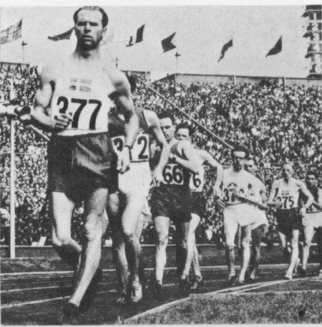
George KNOTT AUS 6th in heat

John Mikaelsson (Sweden) leads the field in the final of the 10,000m walk

Men 50km Walk

21 competitors started 50 km race which was held over a gruelling course in hot conditions. As expected, Ljunggren led from start and had built his lead to 40 seconds by the 5 km mark. At the half way mark, passed in 2:12:17, he had increased the lead to 5 minutes with Harold Whitlock, the defending champion, in second and Martineau of Great Britain in third. Whitlock was forced to retire at 35 km and Martineau began to lose further ground. Ljunggren, walking smoothly, entered the stadium nearly a mile in front to win gold. Behind him 48 year old Tebbs Lloyd-Johnson made a superlative effort to move up into second place, only to give way to Gaston in the closing stages. With his third place, Lloyd-Johnson became the oldest person ever to win an Olympic track and field medal. 16 walkers finished the event, 5 retired during the race and there were no disqualifications.

- John LJUNGGREN SWE 4:41:52
- Gaston GODEL SWI 4:48:17
- T. LLOYD JOHNSON GBR 4:48:31
- Edgar BRUUN NOR 4:53:18
- Harold MARTINEAU GBR 4:53:58
- Rune BJURSTROM SWE 4:56:43
- Pierre MAZILLE FRA 5:01:40
- Claude HUBERT FRA 5:03:12
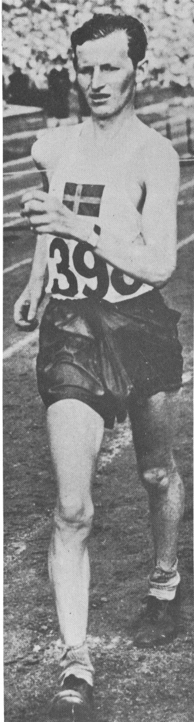

John Ljunggren (Sweden) wins the 50 km racewalk with a flawless walk

George Knott was Australia’s sole walking representative in these Games.
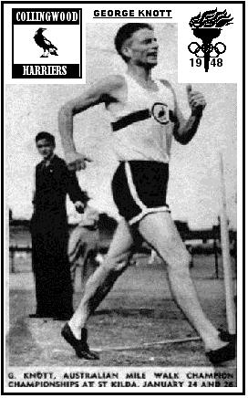
George joined the Collingwood Harriers in 1929 and enjoyed an athletics career that lasted some 70 years. He competed in many events as most did then, but preferred middle distance and pole vault. In 1930 he had his first race walk in a club championship, and from then on mixed running and walking.

George improved his times and finally won his first championship medal in 1936 – 3rd in the Victorian 1 mile title. He followed this up with a win in the Victorian 1 mile event in 1938 was placed second to Athol Stubbs in the inaugural Australian 10,000m walk championship in 1939 in the good time of 46:11. With this success highlighting his rapidly rising star, he then won the local double in 1940 (Victorian 1 mile and 3 mile titles).

By 1940, George was VAWC club captain and Victoria’s top walker but the increasing effects of the war saw competitions stopped and VAWC disbanded and his career on hold.

It was not until 1946 that re-establishment occurred and after things settled down, he was in top form once again. He won the 1946 Victorian 1 mile and 3 mile titles and upped his distance to win the Victorian 10 mile title. Then in 1947, he won the Australian 1 mile (6:31.4) and 10,000m (49:08) titles to stake his claim as the top Australian walker.

But it was in 1948 that he really set the crowds talking with wins in the inaugural Australian 2 mile walk (13:37.2) and the Victorian 1 mile walk (6:23.2) and Victorian 10,000m walk (42.51.6). His 1 mile time was less than one second outside Bill Murray’s Australasian record and his 10,000m time was a staggering world best. It was nominated for world record status but was not accepted due to technical deficiencies in the running of the event.

These outstanding performances gained him selection for the 1948 Olympics in London. There he finished 6th in his heat in the 10,000m walk and just missed out on qualifying for the final (only the first 5 in each heat made it through).

This effectively marked the end of his career as a top walker. He had other things to do with his life. However, he continued to race A grade at Interclub for many years, and would step in when the team was short of a walker, and he continued in the lower grades until the 1970s.

George died in early 2001 at the age of 90, leaving a legacy of 70 years of involvement in athletics as both a fierce competitor and as an official.

1952 Helsinki

Controversy over style, ever a troubling issue, came to a crisis in the 1950s and virtually ended international track walking. For the 1950 European Championships, Britain had two Sheffield walkers, Roland Hardy and Laurence Allen, whose performances in Britain (Hardy had won the AAA 2 and 7 miles in outstanding times and Allen was the RWA 10 and 20 miles champion) made them strong prospects for medals. This they confirmed by establishing such a lead in the 10,000 m that it seemed they would not be caught. However, an old campaigner by the name of Fritz Schwab (the son of Switzerland’s Arthur Schwab, who won the 50 km silver medal in 1936), raised what might charitably be termed a dashing finish and reached the line first. When it was announced that the result had been referred to the Jury of Appeal, justice seemed about to be done. Yet to general amazement, Schwab's victory was confirmed, and Hardy and Allen disqualified! The British team manager, Jack Crump, described it as 'the most atrociously unfair occurrence which I have ever known in more than twenty years of first-class athletics'. In the protracted debate that followed, it was argued that the human eye was incapable of telling whether an 8 mph walker was 'lifting'. Films and photographs were studied minutely; even Bobby Bridge from pre-World War I days had his reputation dented by the evidence.

Hardy and Allen continued to satisfy English judges. Hardy reduced the AAA 2 miles best to 13 min 27.8 sec and the 7 miles to 50 min 5.6 sec. They went to the 1952 Olympic Games as favourites for the 10,000m walk.

Men 10km Walk

Two heats were again used to decide who of the 23 entrants would make the final. Hardy and Allen were controversially disqualified in these heats. Bruno Junks of U.S.S.R. was the fastest qualifier in 45:05, 5 seconds ahead of John Mikaelsson, the defending champion. His Swedish compatriot Verner Hardmo still held the World Record at 42:39.6 but had now retired.

The final saw the 38 year old Mikaelsson win by over 100 yards in a new Olympic record time of 45:02.8 in impeccably fair style. But the final is better remembered for the tussle to decide the minor medals. Schwab, chasing second place, produced another of his fleet-footed finishes, travelling at such speed that the Chief Judge had to run hard beside him to observe his style. Junk manfully met the challenge, and the pair sprinted to a photo-finish which palpably showed both men running. Yet there was no disqualification.

The judges, who had disqualified seven men in the heats and final, were made to look foolish. The controversies that resulted from this incident led Olympic officials to drop the 10,000 meters event and replace it with a 20 kilometre contest in 1956.

Bruno Junk became the first ever Russian medallist. This was the start of the Eastern European domination which has continued to the present day.

- John MIKAELSSON SWE 45.02.8 OR
- Fritz SCHWAB SWI 45.41.0
- Bruno JUNK EST 45.41.0
- Louis CHEVALIER FRA 45.50.4
- George COLEMAN GBR 46.06.8
- Ivan YARMYSH UKR 46.07.0
- Emile MAGGI FRA 46.08.0
- Bruno FAIT ITA 46.25.6
- Don KEANE AUS 47:47.0

Men 50km Walk

This event saw 31 starters, the biggest Olympic walk yet staged. Antal Raka of Hungary had set a new 50 km World Record of 4:31:21.6 only 2 months earlier so was co-favourite with 1950 European Championship winner Guiseppe Dordoni.

It was Dordoni who came out on top, scoring a resounding win in a new Olympic record of 4:28:07 and adding yet another Italian Gold Medal to those previously own by Frigerio. But his reign at the top was short lived as young Josef Dolezal followed up his Olympic silver with a sting of World Records, starting with a 2 Hour Record of 25.595 km and a 30 km standard of 2:20:40.2 in the one race in October 1952 and then taking 20 km Record with 1:30:26.4 in November 1953. George Whitlock, the younger brother of 1936 champion Harold Whitlock, was 4th. In marked contrast to the 10,000m track walk, there were no disqualifications or controversies in the 50 km walk.
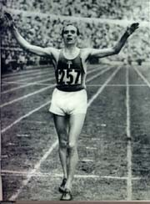

Dordoni raises his arms in triumph as he crosses the finishing line to win gold

- Giuseppe DORDONI ITA 4:28:07.8 OR
- Josef DOLEZAL CZE 4:30:17.8
- Antal RAKA HUN 4:31:27.2
- George WHITLOCK GBR 4:32:21.0
- Sergei LOBASTOV RUS 4:32:34.2
- Vladimir UKHOV RUS 4:32:51.6
- Dumitru PARASCHIVESCU ROM 4:41:05.2
- Ionescu BABOIE ROM 4:41:52.8

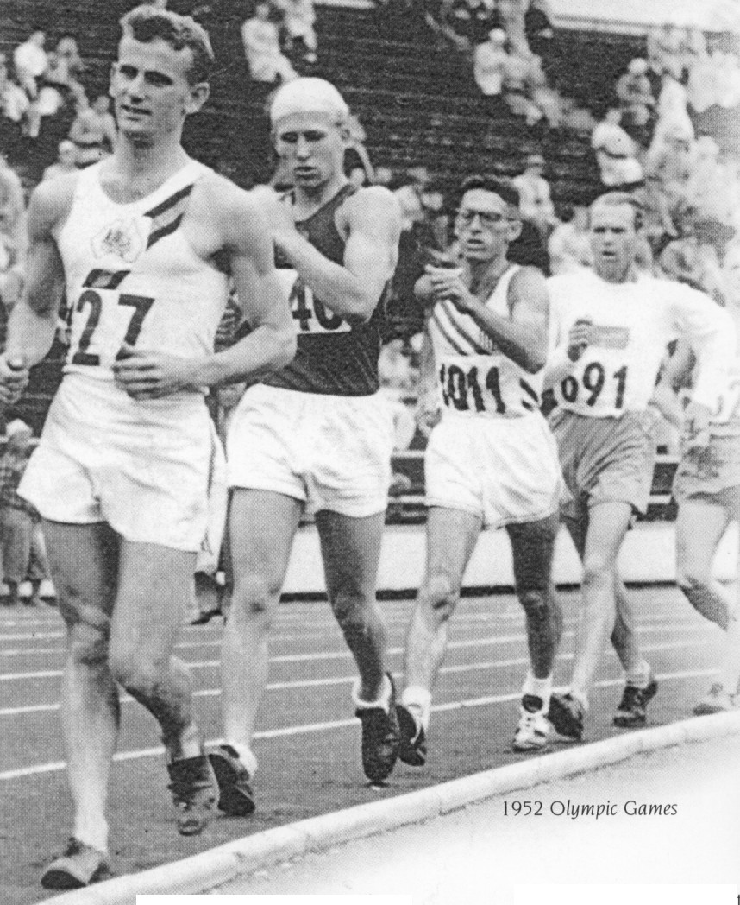
The sole Australian representative at these Olympics was Western Australian walker Don Keane.

Taken in the early stages of the first heat in the 1952 Olympic 10,000m track walk, the photo shows Don (number 27) in front of Bruno Junk (USSR), Henry Lasko (USA), John Michaelson (SWE) and Chevalier (FRA).

In his first year as a senior, he astounded all by winning the 1950 Australian Track Championship in Adelaide, beating Athol Stubbs by 6 inches. Stubbs had won 3 of the last 4 Australian Track Championships and was considered unbeatable at this stage. Don’s time of 13:43 was a new Australian record.

He went on to win another six titles over that distance (1951, 1952, 1953, 1954, 1957 and 1958). He and Ross Haywood share the record of 7 national track championship victories.

With his Australian championship wins in 1950-1952, he was an obvious selection for the 1952 Games in Helsinki and, at only 21 years of age, he competed in the Olympic 10,000m track walk. He led the first heat through the 5000m mark in 22:26 before settling back and finishing 5th (46:55) to ensure his place in the final. There he recorded a fine 10th (47:37).

1956 Melbourne

This was an era when Eastern European walkers had rewritten the record books and, at the height of the Cold War, the stage was set for an East versus West confrontation. The Games were much smaller than the previous ones (2,800 competitors in 1956 compared to over 4,000 in 1952) and only 21 competitors contested each of the racewalks.

The 20 km was expected to be an all Russian affair with Vladimiiar Golubnichiy setting a 20 km World Record in 1955 with 1:30:02.8 and Leonid Spirin lowering it to 1:28:45.2 in June 1956 and then Mikhail Lavrov lowering it again to 1:27:58.2 in August 1956. Russian Anatoly Vedyarkov held the World Record for the 2 Hour walk with 26.429 km and had lowered the 30 km Record to 2:19:43.0. Czechoslovakian walkers Milan Skroat and Ladislav Mack had swapped the 50 km Record back and forth with Mac finally taking it down to 4:21:07.0 in June 1956.

So many disputes had developed over the judging of the comparatively fast-paced 10,000 metre walk that it was replaced by the less controversial 20 km event.

It just seemed a question of which of the many wonderful Europeans would win the two walks.

Then in late September, Victorian Ted Allsopp set a new World Record distance of 26.117 km for the 2 Hour walk in a race at Olympic Park in Melbourne. In the same race, Don Keane, now Melbourne based, had set new British Empire records for 10 km, 7 miles, 1 hour, 15 km, 10 miles and 20 km. His 20 km time of 1:30:22 was only 10.5 seconds outside the World Record. Suddenly there were two local walkers amongst the favourites.

Men 50km Walk

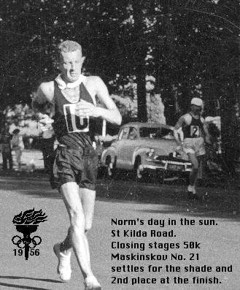
The first event was the 50 km and it promised to be an intriguing race. Being held in late November, the weather was expected to be hot. The favourites were deemed to be Dolezal, Lavrov, Skroat, Ljunggren and Allsopp.

Norm Read of New Zealand near the finish in the 50 km walk.

However, the race was won by a walker who did not feature with the bookies. Norm Read had moved from England to New Zealand in 1954. As the Melbourne Olympics approached, he wrote to the British A.A.A. asking for permission to represent Great Britain as a walker. He was rejected. At first he was rejected in New Zealand as well, but a strong showing in races in Australia and New Zealand paved the way for him. He got his naturalization papers and was ready to fulfill his dream. On the day of the 50km race, Read got lost in the corridors of the stadium and didn't find his way to the track until the other walkers were already standing on the starting line. Maskinskov led over most of the course, with Read two and a half minutes back after 30 kilometres. At 42 kilometres, however, Read caught the tiring Soviet walker and pulled away to a decisive victory. His unexpected win caused wild cheering in the stadium, and a whole section of the New Zealand contingent had to be restrained from streaming onto the track.

Again Ljunggren performed wonderfully to take the bronze while Ray Smith with 6th and Ron Crawford with 13th both showed that Australia was on the way up as a walking nation.

- Norman READ NZL 4:30:42.8
- Yevgeny MASKINSKOV SOV 4:32:57.0
- John LJUNGGREN SWE 4:35:02.0
- Abdon PAMICH ITA 4:39:00.0
- Antal ROKA HUN 4:50:09.0
- Raymond SMITH AUS 4:56:08.0
- Adolf WEINACKER USA 5:00:16.0
- Albert JOHNSON GBR 5:02:19.0
- Ron CRAWFORD AUS 5:22:35.0
Ted ALLSOPP AUS DQ

The particulars of Ted Allsopp’s Olympic participation make for interesting reading. When he fulfilled the live-in requirement and moved into the Olympic Village with the other athletes, he was forced to leave his wife Ann who was soon to give berth. On the evening before the 50 km walk, he want to bed early, having no idea that Ann was about to go into labour. About 11PM, an Australian team official took a telephone call saying that Ann had given birth but the official decided to let Ted get a good night’s sleep and did not tell him of the berth.
The next morning, Ted picked up the Argus newspaper and was surprised to learn that he was a father. The bus duly took the competitors to the MCG and the crowd of 100,000 cheered him as the walkers did their first two laps of the ground before setting off to walk to Springvale and back. At the 12 mile mark, Ted was disqualified, being reported by the two Russian judges and the chief judge, Libotte of Switzerland.

Three days later he walked in the 20 km event and no one challenged his technique. While it was impossible to call into question such judging decisions, it raised once again the spectre that was still lurking in the background in the sport. Had walking really matured as an Olympic sport or was it still plagued by the regional rivalries and human failings that had often been identified with it in previous Olympics?

But as Ted’s Olympic 50 km dreams ended in disaster, Ray Smith took the opportunity that presented itself and walked the race of his life, coming 6th in a finely judged walk in the hot conditions.
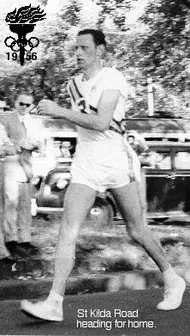

Ray Smith comes home in 6th place in the Olympic 50 km event

Men 20km Walk

This time, as expected, Russians filled the first 3 places. Mikenas, leading after 15 kilometres, received a warning, and resigned himself to second place, urging on Spirin, who had only been placed tenth at the halfway mark. 1948 50 km Gold medallist John Ljunggren did well to take 4th while Don Keane 6th, Ted Allsopp 10th and Ron Crawford 13th all performed admirably for Australia.
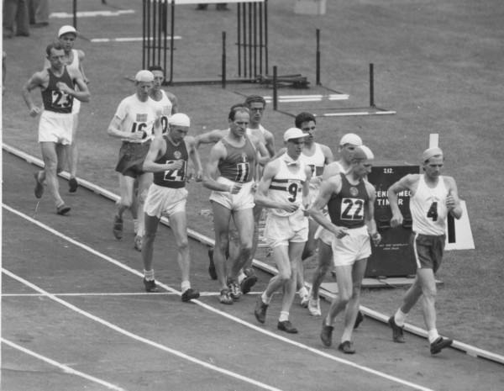

The start of the Olympic 20 km walk. Canada’s Alexander Oakley (4) shares the lead with Russia’s Bruno Iounk (22), followed by Stan Vickers of England (9), defending champion Guiseppe Dordoni of Italy (11), eventual winner Leonid Spirin of Russia (24) and Antanas Mikenas of Russia (23).

Dolezal, after his silver in 1952 and after his many records and championship wins, was a disappointed man when he was one of the 4 walkers disqualified.

- Leonid SPIRIN SOV 1:31:27.4
- Antanas MIKENAS SOV 1:32:03.0
- Bruno JUNK SOV 1:32:12.0
- John LJUNGGREN SWE 1:32:24.0
- Stan VICKERS GBR 1:32:34.2
- Donald KEANE AUS 1:33:52.0
- George COLEMAN GBR 1:34:01.8
- Roland HARDY GBR 1:34:40.4
- Ted ALLSOPP AUS 1:35:43.0
- Ron CRAWFORD AUS 1:39:35.0

Just as Ray had placed 6th in the 50 km event, Don Keane placed 6th in the 20 km event. This result, after his 10th place in Helsinki in 1952, puts him in the small group of Australians with two top-ten Olympic finishes to their credit.

This was one of Australia’s best Olympic walking performances ever with Smith, Keane, Allsopp and Crawford all recording good finishes. Crawford had been NSW based but all the others had been based in Melbourne as had New Zealand Gold medallist Norm Read. They raced weekly at Albert Park and, before their home crowd, rose to the big occasion.

1960 Rome

A record 5,337 competitors gathered in Rome to contest 150 separate events in 18 sports. Cash from football pool profits helped to finance these Games and the many new sports stadiums played host to the biggest sporting event in the Italian capital since the fall of the Roman Empire.

36 walkers contested the 20 km event and 39 fronted for the 50 km event, the biggest fields so far seen in Olympic walking. Italian interest was high with local favourite Abdon Pamich in the 50 km and the stage was set for some classic racing in the hot Mediterranean conditions.

Men 20km Walk

Golubnichiy, a 24-year-old Ukrainian, was the holder of the current world record with 1:27:05.0 and this Olympics marked his first of 5, a feat only matched by Sweden’s John Ljunggren. Like Ljunggren, Golubnichiy went on to win a swag of Olympic medals, this being his first.

Australian Noel Freeman misjudged his closing surge and fell 9 seconds short of victory. His 2nd place makes him Australia’s most successful ever Olympic walker. In retrospect Noel felt he could have won if he had received detailed information in the last few miles – he had not known just how close he was to Golubnichky until it was too late.

Stan Vickers, the 1958 European champion, was third, less than a minute behind the winner. It had been an exciting and close race.

- Vladimir GOLUBNICHIY SOV 1:34:07.2
- Noel FREEMAN AUS 1:34:16.4
- Stan VICKERS GBR 1:34:56.4
- Dieter LINDNER GDR 1:35:33.8
- Norman READ NZL 1:36:59.0
- Lennart BACK SWE 1:37:17.0
- John LJUNGGREN SWE 1:37:59.0
- Ladislav MOC CZE 1:38:32.4
- Ron CRAWFORD AUS 1:39:12.0
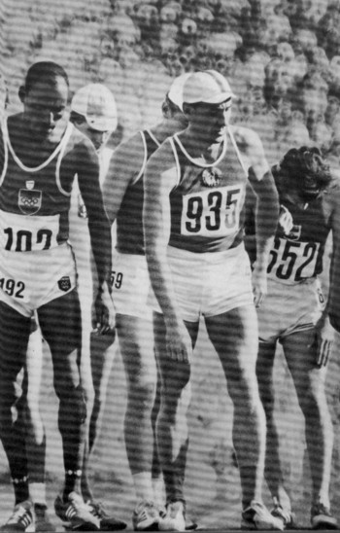

Golubnichiy (935) faces the starter’s gun in the Munich 20 km race where he came second. He walked in 5 Olympics and won 2 Gold, one Silver and 1 Bronze medal in a stellar career.

Men 50km Walk

It seemed harder to make a Russian team than to win an Olympic medal! Maskinskov, the 1958 European Champion (4:17:15) and Lobastov, the World Record holder (4:16:08) both missed out on the trip, being unplaced in their trials. The incredible depth of Russian walking has continued to this very day.

In 1956, British walker Don Thompson had been in fifth place with only 5000 meters to go, when he collapsed and failed to finish. With this bad memory in mind, he decided to acclimatize himself well in advance. But it is not easy to simulate a hot and humid September day in Rome when you live in Cranford, Middlesex. Fortunately, Don Thompson was quite a resourceful person. Several times each week, the 5 foot 5½ inch fire insurance clerk hauled heaters, hot water, and boiling kettles into his bathroom, scaled the doors and windows, and did his exercises in steaming 100º Fahrenheit (38º Centigrade) heat.

Sure enough, the race began in 87º Fahrenheit (31º Centigrade) weather, but Don Thompson was ready. At the halfway point, he found himself in first place, following the disqualification of two of the leaders and the early over-exertions of several others. Surprisingly, his only challenger was 1948 gold medallist John Ljunggren, who was two days shy of his 41st birthday. With 5000 meters to go, the two men were only one second apart. But then Thompson managed to pull away by 18 seconds over the next two kilometres, a lead that he was able to maintain the rest of the way. Four years later in Tokyo, he came 10th in the 50km, capping of a remarkable career.

- Don THOMPSON GBR 4:25:30.0 OR
- John LJUNGGREN SWE 4:25:47.0
- Abdon PAMICH ITA 4:27:55.4
- Aleksandr STCHERBINA SOV 4:31:44.0
- Thomas MISSON GBR 4:33:03.0
- Alexander OAKLEY CAN 4:33:08.6
- Giuseppe DORDONI ITA 4:33:28.8
- Zora SINGH ND 4:37:45.0
Noel FREEMAN AUS DQ
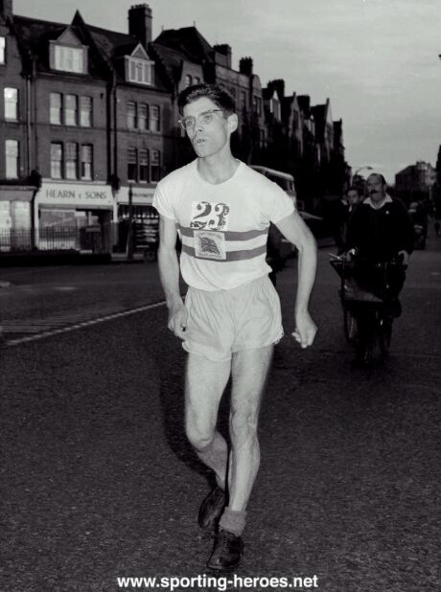
Ron CRAWFORD AUS DQ

A typical photo of Don Thompson who was known as ‘The Mighty Mouse’

In the 50 km event, Noel Freeman was going just as well. With a third of the race over, he and compatriot Ron Crawford were in the lead when disqualified. In the bitter aftermath (he felt he could have won the 50km), the future direction of Noel’s career was perhaps set to be one dogged by controversy.
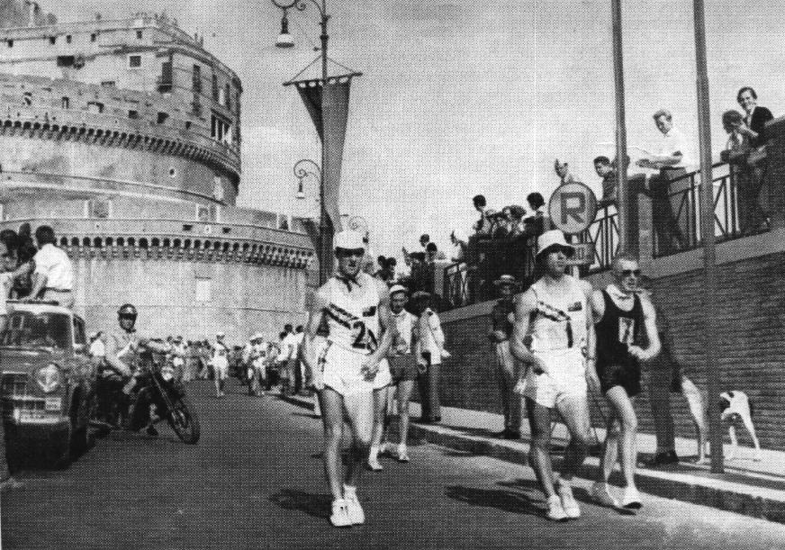

Freeman (2) and Crawford (1) and Read (7) lead in the early stages of the 50 km event. Freeman was controversially disqualified soon after this.

The number of disqualifications were high but overall it provoked none of the controversy of previous Games. In the 20 km event, 7 walkers were taken from the course and 6 walkers were shown the red flag during the 50 km. The oppressive conditions were partly to blame. It was also a reflection of the maturity of the sport in that the judges were now internationally graded and their decisions accepted more than in previous years.

1964 Tokyo

The Lugano Cup had been instituted in 1961 and this meant that the top European walkers now had a virtual world championship every year. Following the 1960 Olympics were the 1961 Lugano Cup, the 1962 European Championships and the 1963 Lugano Cup. The profile of the sport was higher than ever and the large fields of 30 and 34 for the Tokyo Olympic walks included the cream of the sport.

Men 20km Walk

Ken Matthews, an electrician at a power station near his hometown of Sutton Coldfield, had collapsed and failed to finish in 1960 after leading for eight kilometres but since then he had been virtually unbeatable, winning the 20 km at both Lugano Cups and the 1962 European championships. He was an unbackable favourite.

In 1964 he felt he would win only if his wife, Sheila, could join him in Tokyo. His mates agreed and collected £742 to send her along. Sure enough, he crossed the finish line far ahead of the others. Sheila broke through stadium security, rushed onto the track, and gave her husband what was probably the longest victory kiss in Olympic history. At the post race interview, Matthews said, "My legs hurt me at the end of the race. They still do. But I wouldn't mind going dancing now."
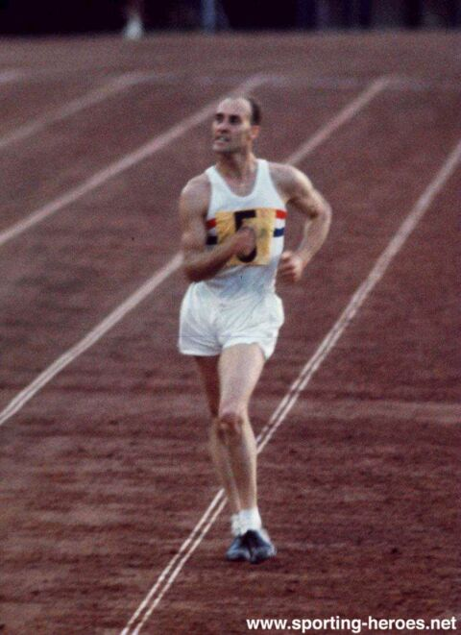

Ken Matthews powers down the final straight to victory in Tokyo

Matthews was one of four British athletes who won Gold in these Games. Three were awarded M.B.E.s. The fourth, Matthews, was not. The reason was never really known and it was not till years later that the misjustice was rectified and Matthews received his award.

Golubnichiy, although still the world record holder, could not match Matthews and faded to third, his second Olympic medal. Sixth-place finisher Ron Zinn died in the Vietnam War less than nine months later. He was 26 years old.

- Ken MATTHEWS GBR 1:29:34.0 OR
- Dieter LINDNER GDR 1:31:13.2
- Vladimir GOLUBNICHIY SOV 1:31:59.4
- Noel FREEMAN AUS 1:32:06.8
- Gennady SOLODOV SOV 1:32:33.0
- Ronald ZINN USA 1:32:43.0
- Boris KHROLOVICH SOV 1:32:45.4
- John EDGINGTON GBR 1:32:46.0
- Ron CRAWFORD AUS 1:38:47
Robert GARDINER AUS DNF

Noel Freeman in his second Olympics and Ron Crawford in his third Olympics, both walked excellently. Once again Freeman was only seconds behind the great Golubnichiy but this time they were relegated to third and fourth.

This second top five Olympic finish cemented Freeman’s spot in Australian Olympic History as the highest credentialled Australian walker ever.

Bob Gardiner, in his first Olympics retired at the 15 km mark with a blister threatening rather than risk his chances in his favoured event – the 50 km walk.

Men 50km Walk

Since taking the bronze in the 1960 50 km walk, Abdom Pamich had, like Matthews, dominated his chosen event. He won the 1961 Lugano Cup 50 km and the 1962 European Championship 50 km and held the World Record at an amazing 4:14:02.4.

The race resolved into a two-man battle between Pamich and Englishman Paul Nihill who had taken the silver medal in the 1963 Lugano Cup 20 km behind Matthews. At the 38-kilometer mark, Pamich was overcome by nausea and forced to take a 15-second vomit break. He regained the lead quickly, however, and fought off Nihill's challenges for the remainder of the race.

- Abdon PAMICH ITA 4:11:12.4 OR
- Paul NIHILL GBR 4:11:31.2
- Ingvar PETTERSON SWE 4:14:17.4
- Burkhard LEUSCHKE GDR 4:15:26.8
- Robert GARDINER AUS 4:17:06.8
- Christoph HOHNE GDR 4:17:41.6
- Anatoly VEDYAKOV SOV 4:19:56.0
- Kurt SAKOWSKI GDR 4:20:31.0
- Ron CRAWFORD AUS 4:24:19.0
- Ted ALLSOPP AUS 4:31:07.0

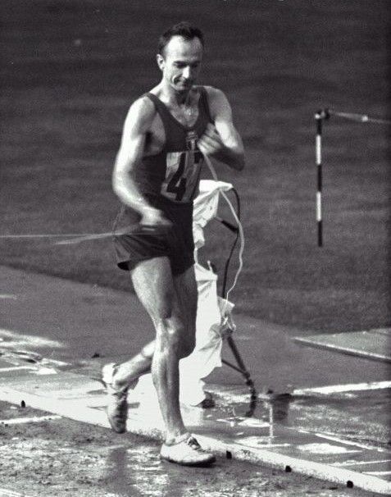
Pamich breaks the finishing tape as he crosses the line to win the 50 km event.

The Australian 50 km team for this Olympics was very strong. Ted Allsopp in his second Olympics, Bob Gardiner in his first Olympics and Ron Crawford in his third Olympics, formed a formidable combination of youth and experience.

Bob Gardiner’s 5th place in the 50 km walk in a new National record of 4:17:06 was in fact a 7 minute PB and marked the start of a wonderful international career which included 3 Olympic selections (1964, 1968 and 1972) and a silver medal at the 1970 Commonwealth Games.
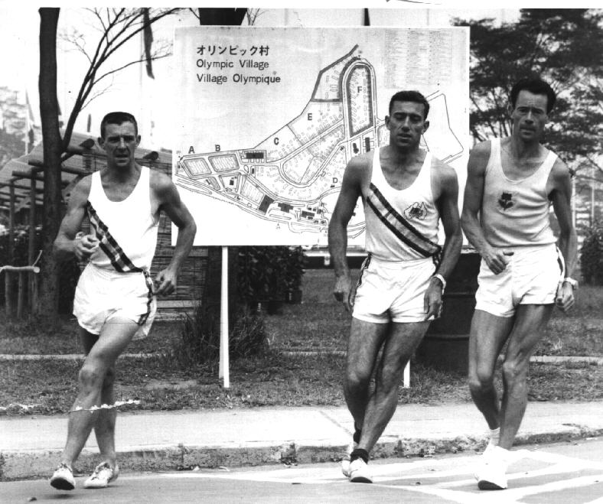
Bob Gardiner, Ron Crawford and Ted Allsopp training in the Olympic Village in Tokyo

1968 Mexico City

One of the most significant events in the history of racewalking quietly took place in 1966 when Mexico hired a group of foreign coaches to help their athletes prepare for the 1968 Olympic Games. Amongst the new arrivals was Polish coach Jerzy Hausleber who went on to revolutionize walking and single handedly lead Mexico to the top of world walking.

An unnown 29 year old army sergeant by the name of Jose Pedraza claimed the nation's first international title when he won the 10,000m walk at the 1966 Central American and Caribbean Games in San Juan, Puerto Rico. He was soon to become world famous.

These Olympic Games remain the most controversial of all time. Commercialism first became an issue in the form of sponsorship and the wearing of branded running shoes (Nike and Adidas). The Black Power movement was beginning to find a voice. The Warsaw Bloc countries had invaded Poland. The Mexican government had brutally put down riots over the poor living conditions of the impoverished population. And finally the altitude of Mexico City (7,347 feet above sea level) was the main topic of discussion for months before the Games. Many sports commentators were predicting deaths in the endurance events and much attention was focussed on the marathon and long walks.

But if there were concerns about the altitude, it did not deter the athletes and good fields of 33 and 36 walkers contested the two walks.

Men 20km Walk

Golubnichiy, in his third Olympics, was always going to be the walker to beat. The World Record holder since 1958 (1:27:05), with Olympic gold and bronze medals already in his possession and coming off silver medals in the 1966 European and the 1967 Lugano Cup 20 km events, he was a big-event performer and the one who was seemed strong enough to beat the altitude.

The event was an unusual one. The starting time was 4.30pm and competitors finished the last 2 km in darkness. Early on, Golubnichiy (USSR) and Laird (USA), who were leading, went straight instead of turning into the circuit. They lost some 20 yards but Golubnichniy caught the leaders again within 200 yards, while Laird never recovered and finished a disappointing 25th.

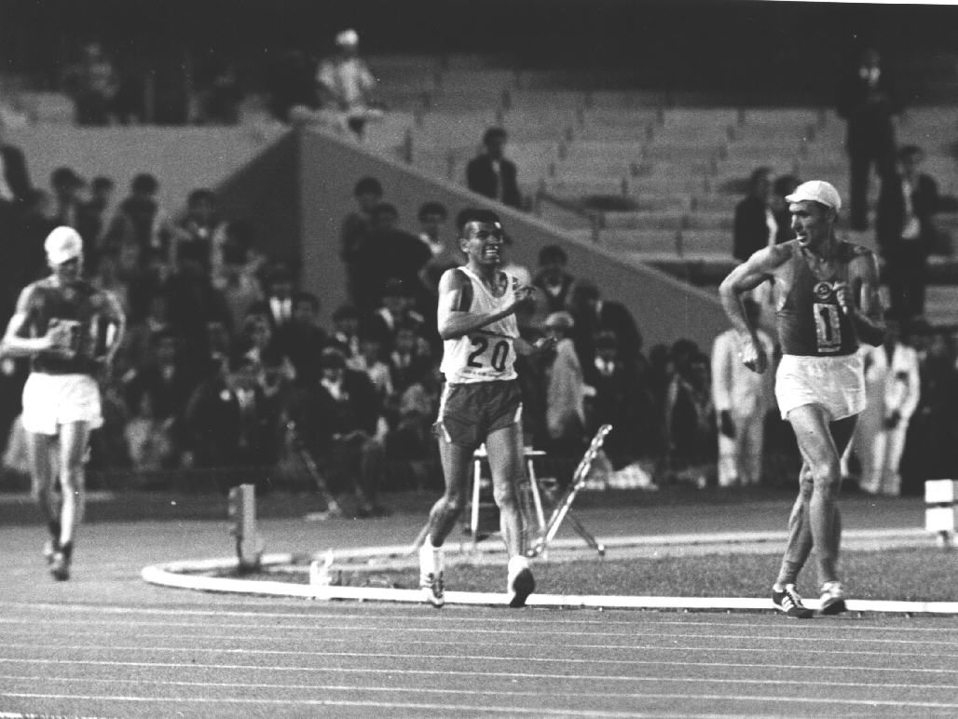
Oxygen debt hit most competitors early in the race and the second half was a struggle for all but the leading few. After 85 minutes of hard walking, Golubnichiy entered the stadium in first place, followed closely by teammate Nikolai Smaga. Then the 60,000-plus spectators went wild as a third walker appeared – Mexican champion Jose Pedraza. Two hundred metres from the finish, Pedraza passed Smaga and set his sights on Golubnichiy. Pedraza's style seemed far from legal and he received three cautions (one step short of a warning). But it would have taken a suicidal judge to disqualify the determined Pedraza while the stadium echoed with chants of "May-hee-co" and "Pay-drah-zah." An international incident was avoided when Golubnichiy drew away slightly in the homestretch to win by a mere three yards.

The famous finish – Golubnichiy looks over his shoulder with 90m to go to see Pedrza closing quickly.

- Volodymyr GOLUBNICHIY SOV 1:33:58.4
- Jose Pedraza ZUNIGA MEX 1:34:00.0
- Nikolai SMAGA SOV 1:34:03.4
- Rudolph HALUZA USA 1:35:00.2
- Gerhard SPERLING GDR 1:35:27.2
- Otto BARCH SOV 1:36.16.8
- Hans REIMANN GDR 1:36:31.4
- Stefan INGVARSSON SWE 1:36:43.4
- Frank CLARK AUS 1:40:06.0

Frank Clark of NSW was the only Australian competitor after Noel Freeman had been left out of the team in very controversial circumstances.

In April 1968, Freeman had won a VAWC 20 km event with a phenomenal 1:29:12. He walked with blistered heels from the 2 mile mark and was under 7 minute mile pace for the first 6 miles before slowing. It was the fastest 20 km time in the world for 1967-68. It was faster than the winning time in both the 1960 and 1964 Olympics and another Olympic selection seemed assured. But the win came at a price as, still suffering with blisters, he was disqualified in the Olympic Trial in May which Clark won in 91:39.

Thus ensued one of the ugliest media frenzies we have seen in Austalia. Noel was adamant he had been ‘robbed’ and many highly placed people like Herb Elliot backed him. Even the A.A.U backed him and they appealed his exclusion from the team. But all to no avail as the AOC stood firm and only Clark made the trip to Mexico.

There is a good chance that he would have beaten his arch rival Golubnichiy and finally won gold. He was a big time competitor and as tough as nails and his form in 1968 was the best ever in his career. If anyone could have conquered the altitude and heat of Mexico City, it might have been Noel Freeman.

Men 50km Walk

East German Christoph Hohne, the World Record holder with 4:10:41 and the winner of the 1965 and 1967 Lugano Cup 50 km events and the holder of the fastest ever road time of 4:03:14, looked unbeatable on paper.

As in the 20 km event, the pundits were proved correct as he drew away after passing the halfway mark, and won by an incredible ten minute margin. This winning margin was not surprising - the weather was hot - a maximum temperature of 85⁰F - and the bitumen road surface reflected heat like an oven top.

Paul Nihill, who collapsed after 44 kilometres, suffered his only defeat in 86 races between December 1967 and June 1970. He finished ninth at the 1972 Olympics.

- Christoph HOHNE GDR 4:20:13.6
- Antal KISS HUN 4:30:17.0
- Larry YOUNG USA 4:31:55.4
- Peter SELZER GDR 4:33:09.8
- Stig-Erik LINDBERG SWE 4:34:05.0
- Vittorio VISINI ITA 4:36:33.2
- Brian ELEY GBR 4:37:33.0
- Jose Pedraza ZUNIGA MEX 4:37:52.0
- Frank CLARK AUS 4:40:13.0
- Bob GARDINER AUS 4:52:29.0

Bob Gardiner was expected to do well in Mexico. He and Noel Freeman had swapped wins in a wonderful winter season of racing at Albert Park. This culminated on August 24 1968 when, in a VAWC Track 50 km event at Melbourne University, Bob won in 4:14:17, setting new Commonwealth, Australian and Victorian records. I was fortunate enough to witness that walk and I still remember the constant pace with which he ate up the 125 laps.

Then 2 weeks later, he finished 4th from a scratch start in the classic Melbourne to Frankston 25 Mile event. His time was a sensational 3:20:46 and he pulled up fresh and looked to have plenty in reserve.

He left for Mexico with high expectations but like most, he had no idea of the toll that the high altitude and heat would exact from his body. In the Olympic 50 km, after a good start, he gradually lost ground and faded back through the field. His last 10 km was walked in the semi darkness with people wandering across the course. His 19th place in 4:52:29 was a disappointment but still a gutsy effort.

NSW walker Frank Clark started slower than Bob and hence fared better. He managed to hold together for a very competitive 12th place finish.

1972 Munich

On September 5 1972, the Olympics finally lost the battle to dissociate itself from the pernicious influence of world politics on sport when Palestinian guerrillas invaded the Israeli team headquarters, taking hostages and killing two team members. In a clumsy attempt to rescue the hostages, 5 Arabs and 11 Israelis were killed. But for all that, the Games went on and the athletes contested their chosen events.

These Games saw East and West Germany win both events. In fact, in the 20km event, it was only Golubnichiy who stopped an East German clean sweep of the medals. The East German sports machine had been born and was now bearing the first fruits of its ruthlessly scientific sports development program. This program would continue to produce champions up until the fall of the Berlin Wall in 1990.

Bob Gardiner had been selected in both the 20 km and 50 km walks but in the final weeks before the team was due to leave for Europe, there were two key withdrawals due to injury - team captain and marathoner John Farrington and Bob. In Bob’s case, a groin injury had flared up at just the wrong time. This disappointment (it would have been Bob’s third Olympic appearance) forced him to reappraise his career and he decided it was time to retire from top level competition.

Men 20km Walk

Three walkers stood out – Frenkel, Reimann and Golubnichiy - and it was hard to predict which of the 3 would win. First Frenkel had lowered the World Record to 1:25:50 in July 1970 and then in an unforgettable race, Frenkel and Reimann had dead-heated to set a new Record of 1:25:19.4 on the same track in Erfurt in June 1972. And Reimann, Golubnichiy and Frenkel had fought out a wonderful 1970 Lugano Cup 20 km in Eschborn in West Germany with Reimann taking the honours.

All 3 were together after 15 kilometres, with the deaf walker, Gerhard Sperling, six seconds behind. Approaching the stadium, Golubnichiy moved ahead, but Frenkel had the strongest finishing kick and was able to enter the stadium with a small but growing lead. Frenkel was described in East German press handouts as a "color designer and decorator."

- Peter FRENKEL GDR 1:26:42.4 OR
- Volodymir GOLUBNICHIY SOV 1:26:55.2
- Hans-Georg REIMANN GDR 1:27:16.6
- Gerhard SPERLING GDR 1:27:55.0
- Mykola SMAHA SOV 1:28:16.6
- Paul NIHILL GBR 1:28:44.4
- Jan ORNOCH POL 1:32:01.6
- 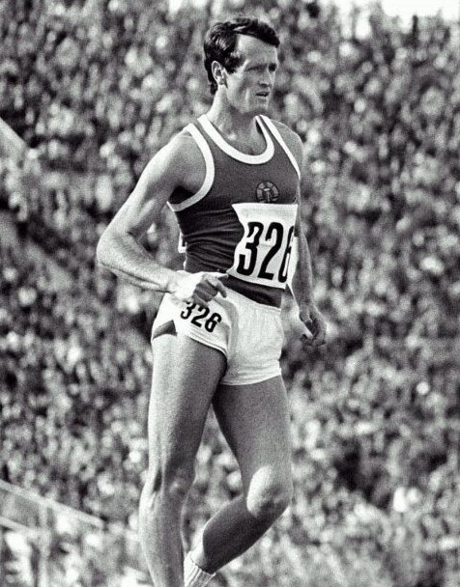Vittorio VISINO ITA 1:32:30.0

Frenkel powers to victory in the 20 km walk.

Men 50km Walk

The winner was expected to be one of defending champion Christoph Holne, fellow East German Peter Selzer and Russian Veniamin Soldatenko. In the 1969 European Championships, Holne had won and Soldatenko was third. In the 1970 Lugano Cup, Holne won and Soldatenko improved to second. In the 1971 European Championships, Soldatenko won in 4:02:22 and Holne was second. Then on September 20, 1971, in a USSR vs GDR 50 km road walk, Soldatenko, with a world best of 3:59:17.8 narrowly beat Peter Selzer who recorded 3:59:21. The 4 hour barrier had finally been broken.

Yet the winner did not come from this elite trio. West German Bernd Kannenberg, a stocky 30 year old, had been, up till now, an aspiring 20 km walker with a best international performance of 9th in the 1971 European championships. Inauspiciously, he had failed to finish in the just completed Olympic 20 km event. Yet he led at every checkpoint in the Olympic 50 km race and, by the 35 km mark, only Kannenberg and Soldatenko were left. Soldatenko was slow in taking his refreshments at the 35 km feeding station so Kannenberg decided to pick up the pace. Soldatenko, worried because he had already received a warning, was unable to respond.

The win was not totally surprising as Kannenberg had been credited with a 3:52 road performance shortly before the Games. There had been general scepticism about the performance but his Olympic victory lends credence to it.

Both walkers easily beat Soldatenko’s ‘official’ road world best time of 3:59:17and Kannenberg became an instant German hero.

- Bernd KANNENBERG GER 3:56:11.6 OR
- Veniamin SOLDATENKO SOV 3:58:24.0
- Larry YOUNG USA 4:00:46.0
- Otto BARTCH SOV 4:01:35.4
- Peter SELZER GDR 4:04:05.4
- Gerhard WIEDNER GER 4:06:26.0
- Vittorio VISINI ITA 4:08:31.4
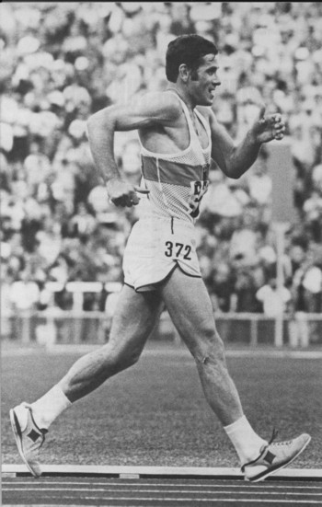
- Gabriel HERNANDEZ MEX 4:12:09.0

Bernd Kannenberg powers down the finishing straight to win the 1972 Olympic 50 km – one of the most well known walking photos of all time. Note the double support contact.

1976 Montreal

In a black segment of Olympic walking history, the 50 km event was dropped after 1972, one of a number of events targeted in a move to reduce the size of what was seen as a bloated monster. Thus Bernd Kanneberg was deprived of the change of back to back Olympic golds. There is little doubt that he would have won. The following analysis of this form in the intervening period confirms this.

He improved his world best road performance 50 km to 3:52:44.6 in a Germany vs. Great Britain match in May 27, 1973 and then recorded an excellent 1:27:19.0 road 20km in a Germany vs. U.S.S.R match on June 16, 1973. He completed the year with a win in the 1973 Lugano Cup 50km in 3:56:50.8, beating Bartsch, Holne and Soldatenko.

With the news now public on the axing of the Olympic 50 km event, he was forced to review his plans. Clearly in a class of his own over 50 km, he turned his back on that event and geared his training towards the 20 km event. The signs looked promising.

He established three world records and one world best track performance in quick succession in 1974. Firstly he set new marks for the 2 hours (27,137 mtrs.) and 30,000m (2:12:58.0) in Kassel on May 11. Then he set new marks for the 20,000m (1:24:45.0) and 1 hour (14,233 mtrs.) in Hamburg on May 25. Then in hot conditions in Rome, he was narrowly beaten by Golbunichiy in the European 20 km Championship. In the 1975 Lugano Cup, he was again second in a major Championship 20 km event in 1:26:20, this time behind Stadtmuller of East Germany.

In November 1975, Kannenberg walked his last 50 km event, a track race in Nerviana in Italy. There he set a World Record of 3:56:51.4. This was the first time 4 hours had been beaten on the track. Another first for the West German.

He now looked ready to seriously threaten in the one remaining walk at Montreal.

Men 20km Walk

The 38 contestants in the 1976 20-kilometer walk covered one of the widest age ranges in the Olympics. Eighteen year-old Bengt Simonsen of Sweden finished 26th while 48-year-old Alex Oakley of Canada placed 35th. History shows that Kannenberg, the world record holder, failed to finish. Losing contact with the leading group, he eventually retired. He did not race again in major competition.

The winner, Daniel Bautista, brought Mexico its first-ever track and field gold medal. He was so dehydrated at the end that he had to drink 10 cans of soft drinks before he could produce enough urine for the dope test.
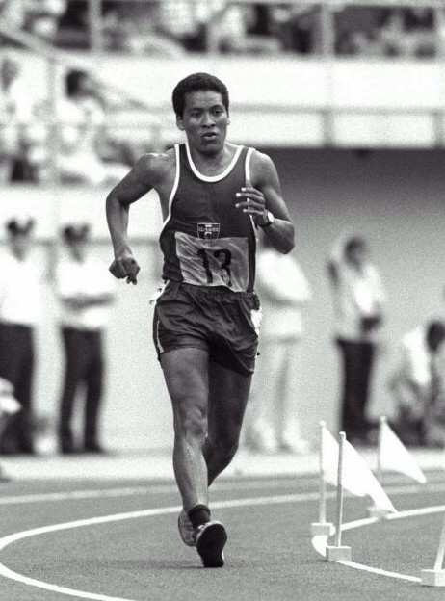
Bautista wins Mexico’s first Gold Medal in the 20 km walk.

- Daniel BAUTISTA MEX 1:24:40.6 OR
- Hans-Georg REIMANN GDR 1:25:13.6
- Peter FRENKEL GDR 1:25:29.4
- Karl-Heinz STADTMULLER GDR 1:26:50.6
- Raul RODRIGUEZ MEX 1:28:18.2
- Armando ZAMBALDO ITA 1:28:25.2
- Vladimir GOLUBNICHIY SOV 1:29:24.6
- Vittorio VISINI ITA 1:29:31.6
- Ross HAYWOOD AUS 1:30:59.0

Australia’s sole walking representative was Victorian Ross Haywood. Ross was a top walker and a top runner and he narrowly missed selection for the 1970 Commonwealth Games in the 3000m steeplechase. Putting this disappointment behind him, he concentrated on his walking, winning 6 successive Australian and Victorian 3000m track walk championships from 1971 to 1976.

He finally earned an Australian vest with selection for the1974 Commonwealth Games 20 mile walk where he finished 7th. He followed this up with selections in both the 20km walk and the marathon in the 1976 Olympics. His 12th placing in the walk (out of 38 finishers) in 1:30:59 cemented his place as an international standard walker.

At the age of 31, he retired from serious training to concentrate on his business in 1978.

Men 50km Walk not held in 1976

The IAAF, always a strong supporter of walking, staged its own IAAF World Championships in Malmo in Sweden in 1976. 42 walkers turned up and Soldatenko won in 3:54:40. One can only guess at the mighty battle which would have ensued if it had remained an Olympic event and Soldatenko and Kannenberg had faced the starter’s gun shoulder to shoulder.
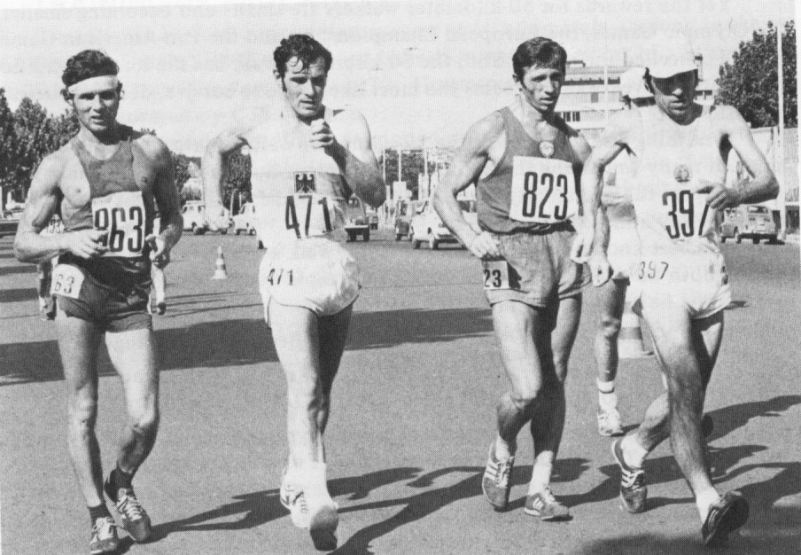
Soldatenko, Kannenbert, Bartsch and Hohne – 4 of the greatest 50 km walkers of all time – denied their chance in the 1976 Olympics

1980 Moscow

This Olympics, held soon after the Russian invasion of Afghanistan, was another politically damaged Games. America, Japan and West Germany were amongst the boycotting nations and Governments in countries like Britain and Australia tried to force their Olympic Committees to join the exodus. To the credit of most Olympic Committees, they ignored their Governments and sent teams, although in many cases without much financial backing.

This was the Olympics that the Mexicans were expected to dominate. Bautista and Gonzalez were unbackable favourites. The depth of Mexican walking meant that a Mexican whitewash of the medals was even possible.

Men 20km Walk

The 20 km World Record had been battered by a series of walkers in the invervening 4 years since Montreal. Initially Mexican Daniel Bautista had lowered it to 1:23:31 in May 1977. Then Russian Anatoliy Solomin had recorded 1:22:59 in April 1979, Frenchman Gerard LeLievre had recorded 1:22:19 in April 1979, Mexican Domingo Colin had recorded 1:20:58 in May 1979 and finally Bautista had retaken it with 1:20:06.8 in October 1979.

Bautista had also won the 1979 World Cup in a dazzling 1:18:49. But the huge improvement came at a cost. There was much discussion on the legality of the new techniques being used by the top competitors. Even in 1976, walk officials had been embarrassed by the publication of photographs that clearly showed gold medal winner Bautista with both feet off the ground during his final lap.

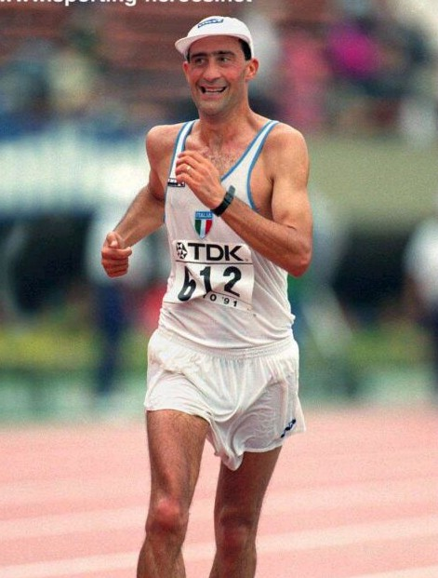
Given this background, it was not surprising that in 1980 they decided to get tough. With just over 2 km to go in the Olympic 20 km event, Bautista was in first place when he was suddenly disqualified and ordered off the course. This left Anatoly Solomin of the U.S.S.R. in front, but a few hundred meters later he too was disqualified. By the end of the race seven walkers had been ordered off by the judges, including three of the six leaders at the 15-kilometer mark. These crackdowns allowed Maurizio Damilano to win a surprise gold medal. His twin brother, Giorgio, finished 11th. Thipsamay Chanthaphone of Laos, celebrating his 19th birthday, crossed the finish line over a half hour after the other walkers, and 21½ minutes slower than any contestant since the event began in 1952. But, unlike Bautista and Solomin, he did finish.

Maurizio DiMilano took gold in 1980, bronze in 1984 and 1988 and took 4th place in the 1992 Olympic 20 km

- Maurizio DAMILANO ITA 1:23:35.5 OR
- Pyotr POCHINCHUK SOV 1:24:45.4
- Roland WIESER GDR 1:25:58.2
- Yevgeny YEVSYU SPA 1:26:45.6
- Raul RODRIGUEZ MEX 1:27:48.6
- Bohdan BULAKOWSKI POL 1:28:36.3
- Karl-Heinz STADTMULLER GDR 1:29:21.7
David SMITH AUS DQ

Men 50km Walk

Mexico was expected to dominate this event. Their walkers had single handedly revolutionised this event. Initially Enrique Vera had set a new mark of 3:56:38.2 and then Raul Gonzales had twice improved on this mark, firstly to 3:52:23 and then to an impossible 3:41.39.0. This last mark stood as the World Record for an unprecedented 18 years and was not broken until 1996.

In the 1979 World Cup, Mexico had taken first (Bermudez in 3:43:36), second (Vera in 3:43:59) and fourth (Gonzales in 3:46:36). But the unbelievable thing was that Gonzales had been the proverbial mile in front and heading for a 3:35 until he had blown at 30 km.

Yet in an inexplicable turn of events, Gonzalez, Bermudez and Bautista all failed to finish the Olympic 50 km event. It was a shattering experience for Mexico and opened the door for Hartwig Gauder of East Germany to take a surprise gold. Gauder, born in West Germany, had moved with his family to East Germany in 1960 and was better known as a 20 km walker, having finished 7th in the 1978 European and 7th in the 1979 World Cup 20 km events. This was his big breakthrough – and an opportunity he perhaps never expected.

Forty-two-year-old Soviet bronze medallist Yevgeny lvchenko had been credited with a controversial time of 3:37:36.0 on the Olympic course on May 23, 1980. He was nearly 20 minutes slower than that in taking the bronze medal.

- Hartwig GAUDER GDR 3:49:24 OR
- Jorge RIBAS SPA 3:51:25
- Yevgeny IVCHENKO SOV 3:56:32
- Bengt SIMONSEN SWE 3:57:08
- Vyacheslav FURSOV SOV 3:58:32
- Jose MARIN SPA 4:03:08
- Stanislav ROLA POL 4:07:07
- Willi SAWALL AUS 4:08:25
David SMITH AUS DNF
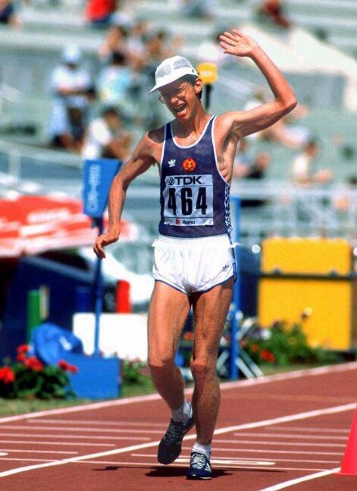

Hartwig Gauder, here shown winning the 1987 World Championshiop 50 km ,secured gold in the 20 km at Moscow

The two Australian representatives were Victorians Willi Sawall and David Smith

Willi Sawall first broke into international rankings with an Australian best time of 3:56:07 in winning the 1979 Lugano Cup trial trial. In Eschborn at the Lugano Cup event he further improved his time to 3:51:08 for 10th place. He had previously recorded a good second in the 1978 Commonwealth Games in Canada but this was definitely a step up.

He followed this with a fine win in April 1980 in the Australian Olympic 50 trial in Adelaide. His time of 3:46:34 broke his previous best and he was rated an Olympic medal hope.

He was never one to rest on his laurels and continued to race hard and fast through the winter season. He won the Victorian 30 km title in another PB (2:10:11) and won the Victorian 12 km teams race in an amazing 49:18. His victory in the Canberra 20mile in June was devastating – his time of 2:16:48 still stands as the best time today – not even the likes of Simon Baker, Nick A’Hern, Dion Russell or Nathan Deakes have been able to approach it. It was perhaps his greatest performance in a long career of great performances.

But he paid a price for these superb performances – a torn groin muscle. This effectively ruined any medal chances in Moscow and his Olympic performance was a big disappointment to him. A cortisone injection enabled him to start and he led early but faded to 15th before rallying to a final place of 8th in 4:08:25. We can only wonder … what if….?
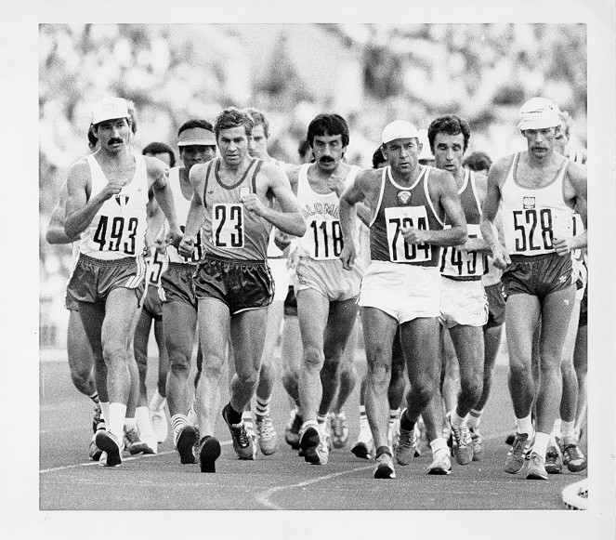
Willi Sawall leads the pack from the stadium in the Olympic 50 km event. Gonzales of Mexico (493), the favourite, failed to finish but came back to win gold in 1984

David Smith started his international career with a fine walk in the 1979 Lugano Cup 20 km (21st in 1:25:36). The 1980 summer season saw Dave set 7 new Australian and Commonwealth records and road bests over distances ranging from 1500m to 10,000m. Yet by season end, he was still number 2 behind Willi who had broken the 1500m time (5:30.8) and 3000m time (11:28.5) to re-establish his number 1 position and it was Willi who won the National 3000m track title in a slick 11:32.

A fine second place in the 1980 Olympic trial (1:27:04) behind Willi ensured that they were both selected for the Moscow Olympics but it was a disappointing experience for Dave. After a successful series of races (4 wins out of 4 races) in Europe, he was one of many disqualifications in the 20 km Olympic event in what seemed to be a judging backlash against criticism of lax judging in the previous few big internationals. It was at the 17 km mark and Dave, in 10th place, was moving up through the field. A top ten place had seemed assured.

1984 Los Angeles

Was this a chance for Mexico to redeem its walking credentials. With Canto holding the 20 km world record and Gonzalez holding the 50 km world record, they were the sentimental favourites and the Mexican population of Los Angeles, second only to that of Mexico City, was out in force for the walks which were held on the streets surrounding the stadium.

Since the disqualifications of 1980, walking times had been slower in what was a case of ‘back to the basics’. Walkers now knew just how fast it was possible to go but they had to hone their techniques to make sure that they could achieve those times and still satisfy the judges.

These Games were severely devalued from a walking perspective with the Eastern European boycott. The cream of the worlds’ elite walkers were conspicuous by their absence. Probably the Mexicans would have won in any case but the minor medals would almost certainly have been differently spread.

Men 20km Walk

Bautista’s 1979 World Record of 1:18:49 had recently been broken by fellow Mexican Ernesto Canto with1:18:39.9 in Fana in May 1984. Canto had won the 1981 World Cup (1:23:52), the 1983 IAAF World Championship (1:20:49) and had finished a close second to Czechoslovakian Pribilinec in the 1983 World Cup (1;19:40). Pribilinec had finished second in the 1982 European Championship (1:23:43), second to Canto in the 1983 World Championship (1:20:59) and had won the 1983 World Cup (1:19:29). These were the two clear favourites.

When the Olympic teams were announced, Pribilinec was not there. Czechoslovakia was amongst the many Eastern Bloc countries that boycotted these Olympics. This left the Mexicans with an easy path to Olympic glory.

Guillaume Leblanc opened up an early lead but, by the halfway point, he had been passed by defending Olympic champion Maurizio Damilano and by Canto. Damilano moved ahead by almost 40 meters in the next five kilometres but was overhauled by Canto and Gonzalez, who were enthusiastically rooted on by the home away from hometown crowd. The two Mexicans entered the stadium to tumultuous applause with Canto prevailing by 40 meters. For the first time in Olympic history, not one walker was disqualified for improper technique. 38 walkers started the event and 38 finished.
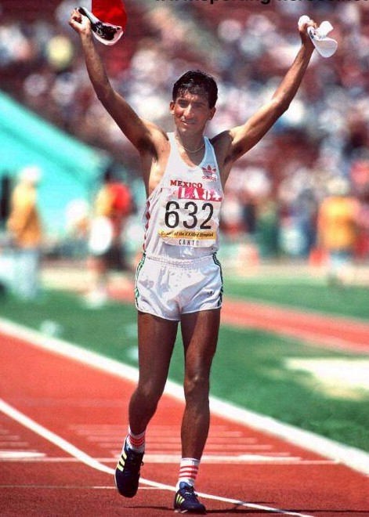

Ernesto Canto acknowledges the crowd as he wins the 20 km walk

- Ernesto CANTO MEX 1:23:13
- Raul GONZALES MEX 1:23:20
- Maurizio DAMILANO ITA 1:23:26
- Guillaume LEBLANC CAN 1:24:29
- Carlo MATTIOLI ITA 1:25:07
- Jose MARIN SPA 1:25:32
- Marco EVONIUK USA 1:25:42
- Erling ANDERSON NOR 1:25:54
- David SMITH AUS 1:26:48
- Simon BAKER AUS 1:27:43
- Willi SAWALL AUS 1:28:24

Men 50km Walk

Gonzales’ World Record of 3:41:39 had not been seriously challenged in the 5 years since he had set it and his past 4 years had been a period of unsurpassed excellence. He had wins in the 1981 World Cup (3:48:30) and the 1983 World Cup (3:45:36) and he was still clearly the best 50 km walker in the world. The one title that he had not yet captured as an Olympic one.

Now a 32-year-old veteran competing in his fourth Olympics, Gonzalez pushed the other walkers through a brutal early pace until the hot sun had worn out all of the leading challengers. Maurizio Damilano was the last to go, staying with Gonzalez for 35 kilometres, before losing contact and then dropping out seven kilometres from the finish. Of the 31 starters, five were disqualified and nine more failed to complete the course. Gonzales finally had his Olympic gold and an Olympic Record to boot.
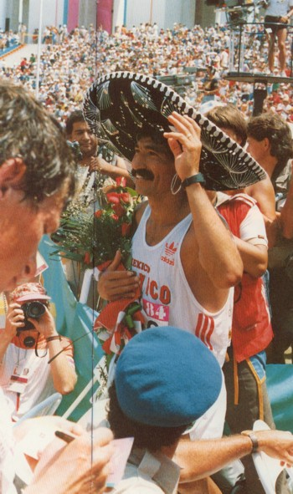

Raul Gonzales dons the Mexican sombrero and celebrates after his historic win

- Raul GONZALEZ MEX 3:47:26 OR
- Bo GUSTAFSSON SWE 3:53:19
- Sandro BELLUCCI ITA 3:53:45
- Reima SALONEN FIN 3:58:30
- Rafaello DUCCHESCHI ITA 3:59:26
- Carl SCHUELER USA 3:59:46
- Jorge LLOPART SPA 4:03:42
- Jose PINTO POR 4:04:42
- Michael HARVEY AUS 4:09:18
Andrew JACHNO AUS DNF
Willi SAWALL AUS DNF
Five Victorians were selected for the walks – Willi Sawall and David Smith for their second Olympics and Andrew Jachno, Simon Baker and Michael Harvey for their first.

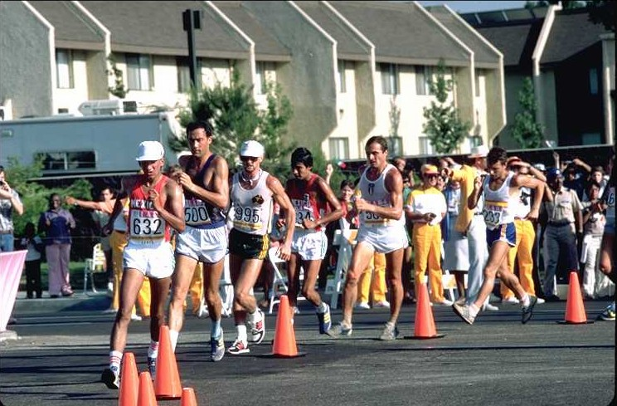
David Smith had done well to finish 15th in the1983 IAAF World Championsip 20 km in Helsinki (1:25:23) and fared better in his second Olympics, finishing 10th in 1:26:48. He then topped of a fine period of walking with a scholarship to the AIS.

Dave Smith sits in 3rd place behind Colin of Mexico and DaMilano of Italy in the Olympic 20 km. Dave came 10th.

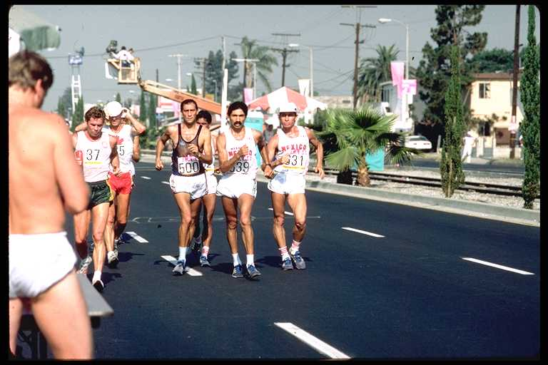
Willi Sawall, at 42 years of age, was struggling with recurrent injuries and forced to battle against the increasingly competitive ranks of the younger walkers. He was selected for both the 20 km (where he finished 16th in 1:28:24) and the 50 km when he failed to finish.

Willi Sawall only knew one way to race – from the front. Here in the 1984 Olympic 20 km event, he is on the left, sharing the lead with DaMilano, Gonzales and Canto, the eventual 3 medallists.

Michael Harvey, at only 21 year of age, was half the age of Willi Sawall and already a seasoned international campaigner, having competed in 2 Lugano Cups. Even though he went on to have an international career spanning 20 years and 10 World Cup representations, he ranks his effort at the 1984 Olympics as his finest hour, finishing 11th in the 50 km walk in a fine 4:09:18.
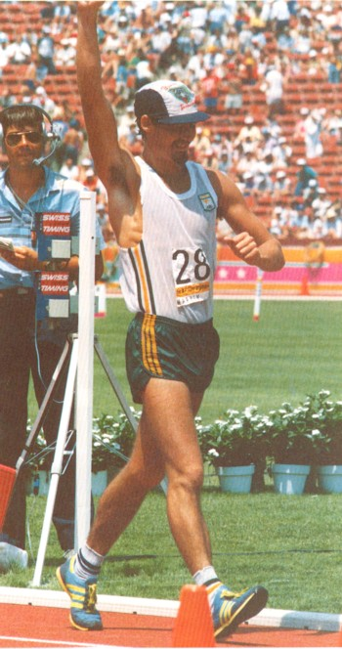

A smiling Mick Harvey finishes 11th in the 50 km walk.

Andrew Jachno was another young walking prodigy and, at only 22 years of age, had already represented Australia in the 1982 Commonwealth Games and the 1983 Racewalking World Cup where he finished 25th in the 20 km event in 1:25:50. An infected wisdom tooth meant he had to walk the 20 km Australian Olympic trial on painkillers and he could only manage a disappointing 6th place in 1:35:46. He would miss Olympic selection unless he tried for the 50 km event. Once his wisdom teeth had been taken out, he was back into training and he surprised everyone, winning the Australian 50 km title in 4:01:02, 9 minutes under the Olympic qualifying standard. It was his first 50 km event and an impressive debut. After the event, he said “I was close to retiring from the event several times because of cramps in both legs. I had to stop very half kilometre to massage my hamstrings but I had a bit of reserve and was able to finish”. But the Los Angeles Olympic 50 km was held in 100 degree heat on a course with no shade. Andrew was one of the 50% of the field who failed to finish.

Simon Baker burst onto the walking scene with a fine 2nd in the 1983 Australian 20 km title in Adelaide in 1:28:00. This gained him his first international vest and a place in the Lugano Cup 20 km team. His walk in the Bergen 20 km was inspirational. His time of 1:24:42 was a PB by over 3 minutes and his placing of 14th was outstanding. He was also selected to represent Australia in the 1983 IAAF World Championship 20 km event in Helsinki but his long season took its toll and he finished 29th in 1:28:09. He gained his Olympic berth with a good 3rd behind Smith and Sawall in 1:25:06. His Olympic walk was a repeat of his 1983 Lugano Cup walk – 14th place. His time of 1:27:43 reflected the hotter conditions. In the space of 2 years, Simon had come out of nowhere and was now amongst our top walkers.

1988 Soeul

Finally an Olympics without boycotts! This time the Olympic walks could be regarded as a genuine World championship and the Eastern Bloc countries were expected to dominate. They did not disappoint.

Men 20km Walk

After missing 1984, Pribilinec was out for revenge. Canto’s World Record of 1:18:40 still stood and Canto had been joined by a new generation of Mexican walkers.

Italian 1980 Gold Medallist Damilano and Pribilinec were seen, along with Canto and fellow Mexican Mercenario, as the favourites. Damilano had shown considerable improvement since his unlikely victory in Moscow. He was second in the 1985 World Cup (1:21:43), second in the 1986 European Championship (1:21:17) and had won the 1987 IAAF World Championship (1:20:45). Pribilinec had won the 1986 European Championship (1:21:17) and come second in the 1987 World Championship (1:21:07). The dark horse was Mexican Mercenario who had beaten them both to win the 1987 World Cup with 1:19:24.

A young East German walker by the name of Ron Weigel (who went on to become the Australian National Coach from 1997 to 2002) had shown outstanding promise over the 50 km distance. After winning the 1983 World Championship 50 km in 3:43:08, he had been denied his first Olympic opportunity by the 1984 boycott. This was followed by a couple of lean years with an inauspicious DNF in the 1985 World Cup 50 km and a DQ in the 1986 European Championship 50 km. In 1987 he finally broke through again with silver (3:41:30) in the World Championship 50 km and gold in the World Cup 50 km in 3:42:26. He entered the Seoul village as 50 km World Record holder and was the hot favourite for the 50 km event. What people had not reckened on was his superb 20 km form.

With only weeks to go before the Olympics, after overseeing his final preparations in the GDR training camp in Bulgaria, his coach added him to the 20 km walk list. Weigel argued that he wanted to concentrate on the 50 km distance and did not want to additionally contest the shorter distance but his objections were overruled. The coach’s judgement proved correct.

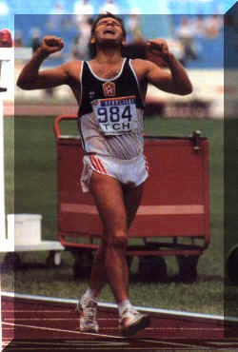
By the 15 km mark, Pribilinec, Weigel and Canto had broken clear of the field. With Canto eventually disqualified, Pribilinec and Weigel entered the stadium less than 10 metres apart. In one of the most exciting Olympic finishes ever seen, Pribilinec had to draw on all his reserves to hold out Weigel for gold. After the line, he collapsed on the track. Weigel knelt over him and tried to extend his contratulations. But the Slovak winner was so exhausted that he was unable to respond. Silently, Weigel kissed him and walked away.
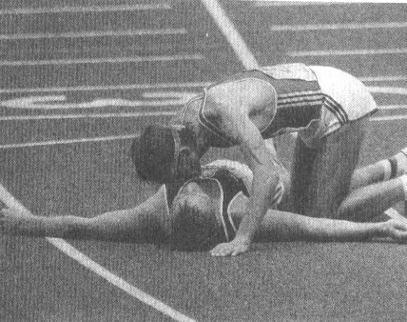

Czech walker Jozef Pribilinec wins their first ever walking gold medal and Ron Weigel silently congratulates him with a kiss
The times were sizzling and there were only 3 disqualifications out of the record field of 53 starters (the disqualifications included the Mexicans Canto and Sanchez). Damilano set the seal on his greatness as a walker with a third Olympic medal while Mercenario was competitive in seventh place but never seriously challenged.

- Jozef Pribilinec CZE 1:19.57 OR
- Ronald Weigel GDR 1:20.00
- Maurizio Damilano ITA 1:20.14
- Jose Marin SPA 1:20.34
- Roman Mrazek TCH 1:20.43
- Mikhail Shchennikov SOV 1:20.47
- Carlos Mercenario MEX 1:20.53
- Axel Noack DDR 1:21.14
- Simon Baker AUS 1:21:47
- Andrew Jachno AUS 1:24:50

Men 50km Walk

With Gonzalez retired, the way was open for a new Olympic champion and Gauder, the 1980 champion, was back after the 1984 boycott. He won the 1985 World Cup in 3:47:31, won the 1986 European Championship in 3:40:55, won the 1987 IAAF World Championship in 3:40:53 and was second in the 1987 World Cup in 3:42:50. Such excellence over an extended period had seldom been seen in walking and he was expected to fight out the gold with Weigel (see comments above).

The only threat seemed the Soviet walker Ivanenko who had finished second to Gauder in the 1986 European Championship in 3:41:54 and was third in the 1987 World Championships in 3:44:02. Ivanenko’s story made for interesting reading. As a 22 year old mechanic repairman at a textile factory, he had watched a television program that said that walking was good therapy for a bad back. The 5-foot 4½-inch Ivanenko began walking the two and a half miles to work. Because he lived in Siberia, he walked fast. One day he was noticed by a coach who began training him in earnest.

In the fastest Olympic 50 km event ever walked, it was Ivanenko who prevailed over Weigel and Gauder, all 3 breaking the 3:40 barrier. They had been together until the 40 km mark when Ivanenko made his decisive break, dropping first Gauder and then Weigel who resigned himself to second place after receiving two warnings for lifting. It was Weigel’s second silver medal of the Games and Gauder earned bronze to add to his 1980 gold.
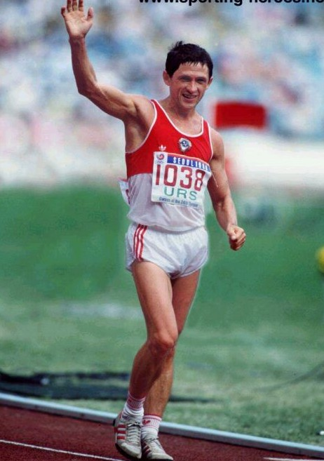

Ivanenko wins yet another Soviet gold medal, this time in the 50 km walk.

- Vyacheslav Ivanenko SOV 3:38.29 OR
- Ronald Weigel GDR 3:38.56
- Hartwig Gauder GDR 3:39.45
- Aleksandr Potashev SOV 3:41.00
- Jose Marin SPA 3:43.03
- Simon Baker AUS 3:44.07
- Bo Gustafsson SWE 3:44.49
- Raffaello Ducceshi ITA 3:45.43
- Andrew Jachno AUS 3:53:33

The two Australian representatives were Simon Baker and Andrew Jachno who had also repped at the 1984 Olympics. Both were now resident at the AIS in Canberra and training partners.

Simon became an overnight Australian celebrity when he walked an unforgettable race in dreadful Edinburgh conditions to win the 1986 Commonwealth Games 30 km with a PB time of 2:07:47. The event was broadcast live on Australian television. Simon took the lead at the 14.5 km mark and powered home through the driving rain to win by over a minute. He celebrated his win with a victory leap past the finishing line and a victory lap – you would rarely see a more excited winner.

He followed this up with a fine 11th in the Racewalking World Cup placing in New York and a PB of 1:21:57. Again another international race and another PB – and the fastest time recorded by an Australian at the Lugano Cup. But like 1983, his tough regime of racing and training took its toll and his subsequent performance in the 20 km at the IAAF World Champs in the heat of Rome was a slightly lower but still good 24th in 1:27:32.

Up till now, Simon had always looked upon himself as a 20 km walker but his coach Craig Hilliard felt it was time to move up to the 50 km distance so October 1987 saw him attempt his first 50 km in Germany. His time of 4:04:30 was a very good first up attempt and broke the Australian Olympic qualifying standard.

His tough task – to walk both the 20km and 50 km event in Seoul – was not easy but the way in which he executed it left no doubt about his real walking capabilities. His 11th place in the 20 km event in 1:21:47 was outstanding but this was overshadowed by his 6th place in the 50 km walk. Journalist Len Johnson described his finish in the 50 km event as “the excited extrovert who spent the 10 minutes after crossing the line falling around like a puppet dangling on tangled strings, joyously celebrating his own performance with every other walker in sight”. The time of 3:44:07 was a PB and a new Commonwealth best.
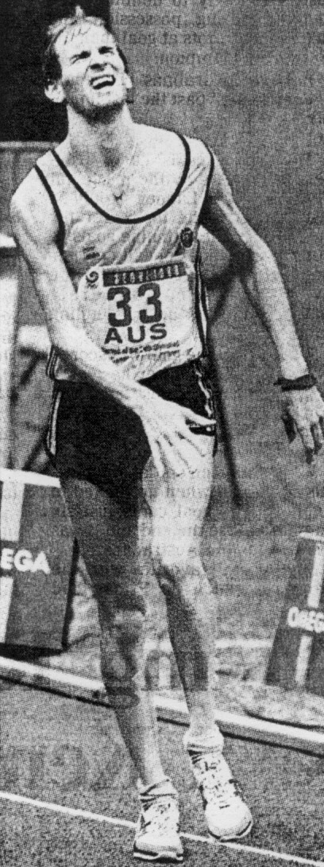
Pain is etched on the face of Simon Baker as he crosses the line to finish the Olympic 20 km walk

This performance showed the two sides of Simon – the hard working athlete who had assiduously trained to achieve his high ranking and the eccentric extrovert. But it worked and he was able to get a lot of good publicity for racewalking.

Coming back form his Olympic success, he fronted for the VRWC 2 hour walk at the Collingwood track on August 20 and set a new National 1 hour record of 14.475km.

Although Andrew Jachno’s Olympic performances were overshadowed by Simon’s, full credit also goes to him for what was a wonderful period of racing. 1987 had been his best year so far with a host of international berths which included the World Indoor 5000m in Indianapolis (15th in 20:19), the World Student Games in Zagreb (4th in 1:27:39), the Racewalking World Cup in New York (37th in 1:25:58) and the IAAF World Championships in Rome (12th in 1:25:50).

In 1988, he was finally awarded an AIS scholarship and moved to Canberra. There he was able to team up with Simon, a training combination that helped them both in their final preparations for Seoul. His 28th place in Seoul in the 20 km walk in 1:24:50 was followed by an even better performance in the 50 km – 19th in 3:53:33. It was a PB by some 8 minutes and placed him third in the Australian all time 50 km rankings.

The great Olympic performances by Andrew and Simon Baker gained them invitations to walk the New York marathon. Andrew finished in 3 hrs 24 mins, one minute ahead of Simon.

1992 Barcelona

A 5 km walk for women had been added to the World Cup in 1979 and then increased to 10 km in 1983. In 1984, a 10 km for women was added to the Pan American Games. In 1986 it was added to the European Championships and to the Asian Games. In 1987, it was added to the IAAF World Championship program and to the African Games. In 1990 it was added to the Commonwealth Games.

World Champions and World Record holders had come and gone while they waited in vain for an Olympic berth. The list included Fawkes of Great Britain, Gustavsson of Sweden, Xu and Yan of China, Diaz of Spain, Strakhova and Krishtop of Russia, Cook and Saxby of Australia, Anders of East Germany and Sidoti of Italy.

After many years of lobbying, a walk for women was finally included on the 1992 Olympic program and Russia was expected to dominate.

Women 10km Walk

The list of favourites included Russians Ivanova (winner of the 1991 World Championships in 42:57) and Strakhova (winner of the 1993 World Cup in 43:55). The Chinese had been gradually building up their rankings but the top Chinese, Chen Yueling, was still only a 44 minute walker in the big competitions and was not really expected to challenge the Russians.She had finished 8th in the 1991 World Championships and had been disqualified in the 1991 World Cup. World record holder Nadezhda Ryaschkina of Russia (41:56) failed to even make the Russian team, an indication of the depth of talent in that country.

But it was the Chinese who turned the tables on her Eastern European rivals in the closest Olympic walk finish ever. Only 1 second separated her and Nikolayeva. Chen subsequently defected to America, wa forced to sit out the 1996 Olympics and unsuccessfully tried for selection in the 2000 Games. Nikolayeva, in contract, has gone on to become perhaps the greatest woman walker of all time, based on her long and outstanding international career.

- Chen Yueling CHN 44.32 OR
- Yelena Nikolayeva CIS 44.33
- Li Chunxiu CHN 44.41
- Sari Essayah FIN 45.08
- Cui Yingzi CHN 45.15
- Madeleine Svensson SWE 45.17
- Anna Rita Sidoti ITA 45.23
- Yelana Sayko CIS 45.23
- Kerry Saxby AUS 46:01
- Gabrielle Blythe AUS 50:13
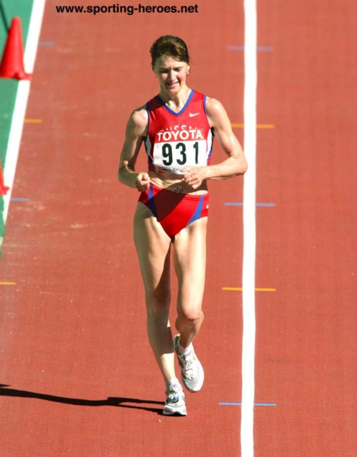

Nikolayeva, second in the 1992 Olympics, won gold in 1996 and won the 2003 World Championships at 37 years of age, thus becoming one of the greatest women walkers of all times.
Men 20 km Walk

First Russian walker Andrey Perlov had lowered the 20 km World Record to 1:18:13 in May 1990 and then Polish walker Pavel Blaszek had lowered it to 1:18:13 in September of that year. However, no one walker dominated the world stage and the various indicator events had produced different champions. The 1989 World Cup was won by Russian walker Kostiukevich, the 1990 European Championships saw a battle between Czechslovakian walker Blazek and Spanish walker Daniel Plaza. The Mexicans dominated the 1990 Pan American Games with the medals going to Canto, Sanchez and Mercenario. Damilano won the 1991 World Championship in Tokyo with a fast 1:19:37 ahead of Russian walker Mikhail Shchennikov but then Schennikov turned the tables and won the 1991 World Cup ahead of Canto.

It was a case of ‘take your pick’. DaMilano, in hot conditions, led the pack for most of the race but, just before the 15 km checkpoint, Plaza. LeBlanc of Canada and Plaza’s Catalan teammate Vanenti Massana shifted gears and pulled away. By the time they reached the steep hill leading to the stadium, Plaza had broken free from the others. Only 800m from the stadium Massana was disqualified while in second place. That left Plaza, revelling in the homecrowd support, to storm home a clear winner. Damilano was the best of the other big guns, finishing 4th in his fourth and last Olympic appearance. He had won gold in 1980 and silver in 1984 and 1988. Leblanc, fresh from his 1990 Commonwealth Games win over Andrew Jachno, took silver for the best international result of his career while Italy showed its depth by taking the bronze with de Benedictis. A young Polish walker by the name of Robert Korzenioski was amongst the DNFs.

- Daniel Plaza SPA 1:21.45
- Guillaume Leblanc CAN 1:22.25
- Giovanni de Benedictis ITA 1:23.11
- Maurizio Damilano ITA 1:23.39
- Chen Shaoguo CHN 1:24.06
- Jimmy McDonald IRE 1:25.16
- Daniel Garcia MEX 1:25.35
- Sandor Urbanik HUN 1:26.08
- Nick A’Hern AUS 1:31:39
- Andrew Jachno AUS 1:36:49
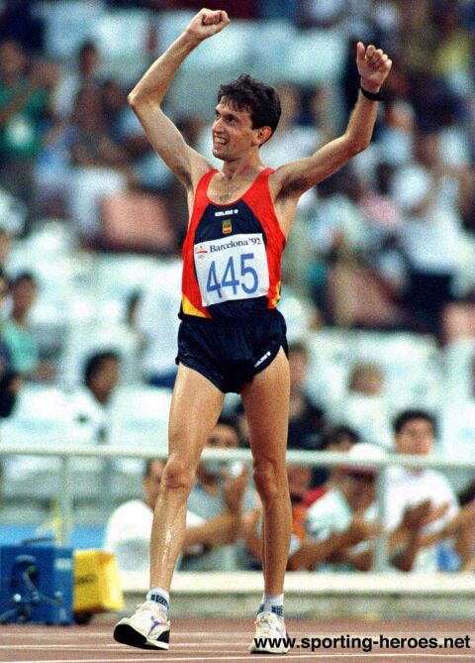
Daniel Plaza of Spain wins the 20 km walk in front of an jubilant home crowd

Men 50 km Walk

The 50 km was also up for grabs with the main contenders being Perlov, Potashov, Baker, Mercenario and Weigel. Perlov’s credentials made for interesting reading. He was second to Australian Simon Baker in the 1989 World Cup 50 km (3:44:12), briefly held the 20 km World Record in 1990 with a time of 1:18:13, won the 1990 European Championship in 3:54:36 and was second to teammate Aleksandr Potashov in the 1991 IAAF World Championship in 3:53:09 (they tried to deadheat in finishing arm to arm but the judrges ruled that Potashov had crossed the line first). The only blot on his otherwise wonderful record was a disqualification after finishing first in the 1991 World Cup which was subsequently awarded to the Mexican Mercenario in 3:42:03 ahead of Baker and Weigel.

The Barcelona 50 km was a wonderful event to watch. Potashov took the early lead but was disqualified after 20 km. Valentin Kononen of Finland then took over and opened a 42 second gap at the 30 km mark. By 35 km, he had been reeled in by Mercenario, Perlov and Robert Korzeniowski of Poland. At the 40 km refreshment stand, without warning, Perlov shot ahead. Mercenario and Korzeniowski were unable to keep up with his pace. At the entrance to the stadium,Korzeniowski, in second place,wad informed that he had been disqualified. In fact, he had received 5 warnings but it took a while for the recording system to catch up with him. That left Perlov to win by nearly 2 minutes. Mercenario won yet another medal for Mexico while Weigel followed up his two silver medals in 1988 with a bronze.
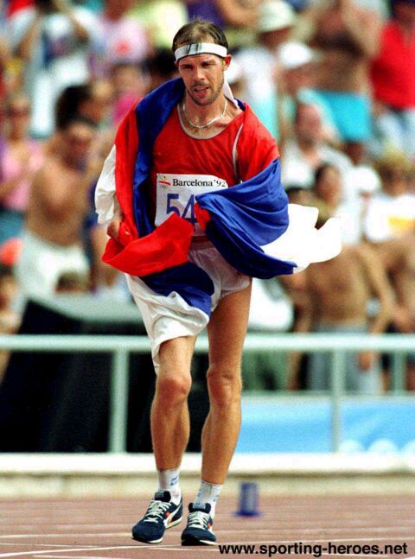
Perlov does a victory lap, wrapped in his National flag, after winning the 50 km.

- Andrei Perlov CIS 3:50.13
- Carlos Mercenario MEX 3:52.09
- Ronald Weigel GER 3:53.45
- Valery Spitsyn CIS 3:54.39
- Roman Mrazek CZE 3.55.21
- Hartwig Gauder GER 3:56.47
- Valentin Kononen FIN 3:57.21
- Miguel Rodriguez MEX 3:58.26
- Simon Baker AUS 4:08:11

Five Australians contested the 1992 Olympic walks. Kerry Saxby, Gabrielle Blythe and Nick A’Herne competed in their first Games while Andrew Jachno and Simon Baker competed in their third successive Games.

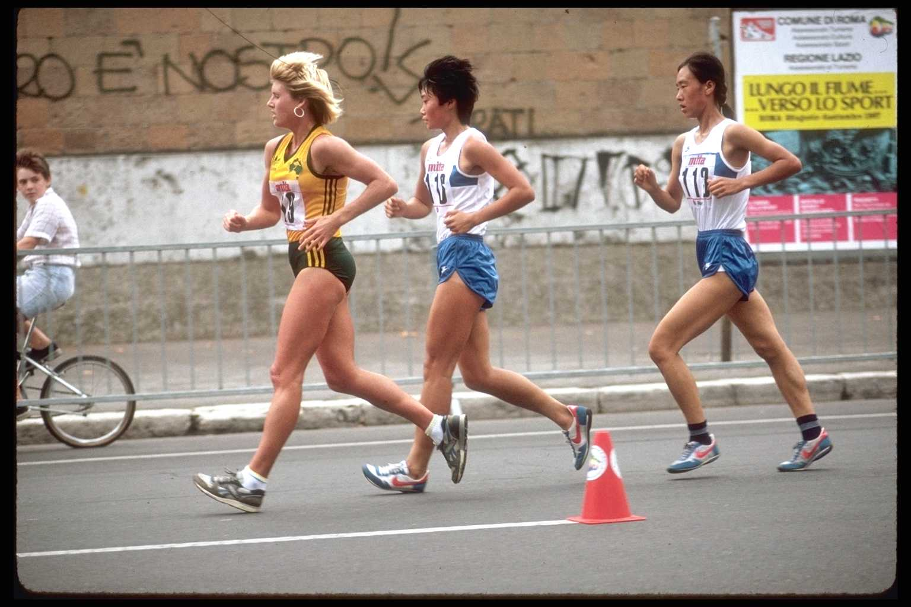
Kerry Saxby, born in 1961, had waited a long time for her chance to walk at the Olympic level. She had been setting world records since the mid 1980s and her international record included numerous placings at World Cup and World Championship events. She was the first women to break 45 minutes, then 44 minutes, then 43 minutes for the 10 km and the first woman to break 21 minutes for the 5 km walk. Her devastating sustained pace was truly awesome.

This photo of Kerry shows her leading Hong Yan and Ping Guan of China in the 1987 World Championship in Rome. She came 2nd in that race. The speed of the walkers is apparent in the photo.

Kerry’s 15th place in 46:01 was a disappointing result for her, coming as it did, nestled between two Commonwealth Games gold medals (1990 and 1994) and two fifth places in consecutive Racewalking World Cups (1991 and 1993).

Gabrielle Blythe, who had represented Australia in the 1986 and 1988 World Junior Championships (7th on both occasions) had all but retired and it was only the lure of the Olympics that prompted her to intensify her efforts. She was rewarded with an AIS scholarship and she then started on her path to the Barcelona.
She seemed initially to have missed out on any chance of Olympic selection when she finished 3rd in the Olympic 10 km trial (she was beaten by both Kerry Saxby and Lorraine Jachno) in a time well outside the Australian Olympic qualifying standard of 45:30. With Kerry and Lorraine in Europe chasing times and races, Gabrielle won the Australian 20 km title in Melbourne on May 24 in 1:40:02. In this race, her first 10km split was 44:21. She then backed this up with 44:27 in La Caruna in Europe. So now she had 2 Olympic qualifiers to her name and it was not surprising when she was added to the team. However, the big shock was Lorraine Jachno’s omission even though she had 3 qualifying performances and had come 2nd at the official trial.

Gabrielle’s Barcelona performance of 50:13 for 31st place was a disappointment after her great 10 km qualifiers. The effort in making the team had been at a great cost and her form deserted her at the vital time.
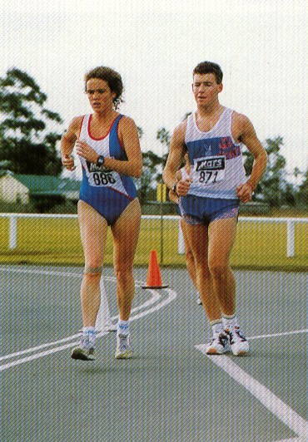
Gabrielle Blythe and Dion Russell in 1991

Throughout 1993, Gabrielle continued to improve and represented Australia at the Racewalking World Cup and the IAAF World Championships. But, surprisingly, at the end of 1993, she forfeited her AIS scholarship and returned to Melbourne. Soon afterwards, she made the decision to retire. It had been a short but impressive career.

Andrew Jachno suffered a huge setback in preparing for his third Olympic berth – he contacted glandular fever. He withdrew from the 1991 IAAF World Championship team as the illness lingered and was just coming back into form again in early 1992 when, applying ice to a sore knee, he froze one of the key nerves in the knee and electrical impulses to the shin were impaired. The diagnosis – wait for it to repair naturally – the timeframe 3 to 6 months.

With his preparation in tatters, he looked like having to miss the Olympic 20 km trial. AIS physio Peter Stanton came to the rescue and devised a contraption using a bicycle inner – the tube was attached to the shoelaces and taped under the kneecap. The result – the toes were held firm at 90º to the shin and he had the necessary control to pull the foot forward. Some people questioned the legality of the device but it was ruled by AA to be within the rules and he was able to line up for the trial. He struggled in in 3rd place in 1:23:36. A few days later he fronted for the Australian 5000m track title which became an unforgettable 3 way tussle between him, Dave Smith and Simon Baker. Dave eventually won in 19:23 and Andrew crossed the line in 2nd place, only a couple of seconds behind, to find that the referee had ruled his support strap illegal and disqualified him.

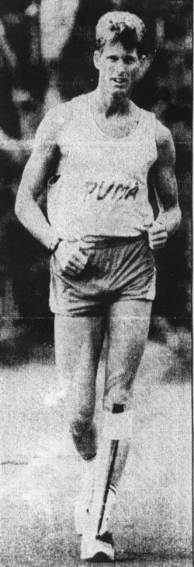
This raised a whole new controversy as to whether his 20 km place should be reviewed. But common sense prevailed and the 20 km result was ratified.

Andrew sports his controversial leg strap

He was named in the Olympic B squad and, with the shin responding to treatment, he was off to Europe to chase further performances to confirm his selection. In May he had a series of races that showed he was regaining form. First he placed 2nd in the German Olympic Games 20 km trial in 1:21:37, then followed this up with 38:49 for 2nd place in a road 10km event in Copenhagen and a week later finished 4th in a track 20 km in Bergen, recording 1:21:34.1 for a new Victorian record. But the races took a toll on his limited preparation and he faded in the heat at Barcelona to finish a disappointed 31st place in 1:36:49. This was his last international walk.

Simon Baker, also in his third Olympics, was suffering the effects of many years of hard and long training. He had won the 1989 World Cup 50 km in 3:43:13, then come home a poor 7th with back problems in the 1990 Commonwealth Games in Auckland but then resurrected his career in 1991 with 4th in the Goodwill Games 20 km in 1:23:52 and 2nd in the World Cup 50 km in 3:46:36. As such, he was one of the favourites for the 1992 Games but the risk of injury remained a potential problem.

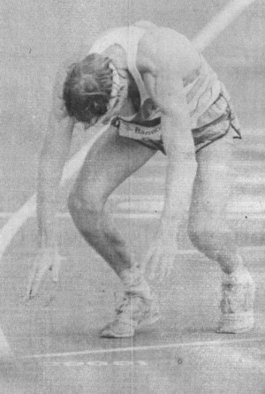
To cap of his wonderful career thus far, AA managing director Neil King announced in April 1992 that Simon was the recipient of the prestigious E.H. Flack award for distinguished services to Australian Athletics. He was only the seventh recipient of this prestigious award. He must have been on a high as he set forth for Europe once again. There he recorded 2:07:43 in a 30km race in Milan in May and backed up a week later for 1:23:09 in a 20 km race in Norway. He looked in good shape but, come the 1992 Olympic walk in Barcelona, he finished 19th in 4:08:11 and collapsed after crossing the line. He was carried from the track on a stretcher and hurried to the medical centre for observation. Simon,when interviewed by the press later, said that he had been in pain for the last 25 km of the event and that he had never suffered pain for that long in a race before.

Simon Baker collapes after crossing the finishing line in 19th place in the 50 km walk.

This was probably a disappointing result for Simon but he would continue on for a further four years and gain yet another Olympic selection to make a record four.

Nick A’Hern had burst into the senior ranks in 1990 after accepting an AIS scholarship. His fourth place in the Goodwill Games 20 km in 83:50 confirmed his international credentials and his 22nd place in the Olympic 20 km in 91:39 was another step forward. Over the next 8 years, he was at the forefront of Australian walking and he competed with distinction in two further Olympics.
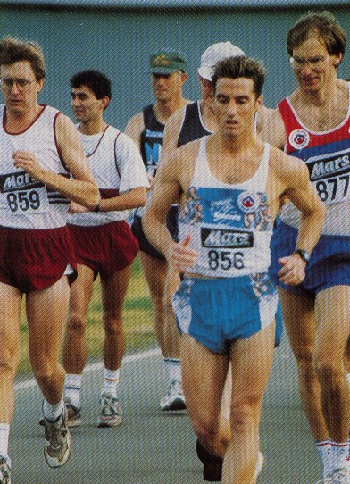

Nick A’Hern leads Simon Baker in the early stages of the 1992 Olympic 20 km trial

1996 Atlanta

Seven Australian walkers were represented for the Atlanta Olympics – the most ever. Australia was building up for the 2000 Olympics in Sydney and a huge team of athletes and officials was assembled and sent to Atlanta.

Leading the walking team was Simon Baker who at 38 years of age, was competing at his fourth Olympics. Alongside Simon was Kerry Saxby who, although in only her second Olympics, was just as experienced and well known on the world scene.

Nick A’Hern had assumed the mantle of our top male walker and he was contesting his second Olympics. The other 4 walkers were all first time Olympians – Anne Manning, Jane Saville, Dion Russell and Duane Cousins.

For the first time, the Victorian stranglehold on walking looked broken. Of the 7 walkers, 4 were from NSW and only 3 were from Victoria.

Women 10km Walk

If there was one walker who stood out amongst the many, it was Nikolayeva of Russia. Silver medallist in the 1992 Olympic walk, third in the 1993 World cup, third in the 1994 European championship, third in the 1995 World Championship and second in the 1995 World cup, all in the 42+ minute area. In every case, it had been a different winner – Yueling of China, Yan Wang of China, Essayah of Finland, Stankina of Russia and Hongmiao of China. The stage was set.

Nikolayeva did not disappoint, leading from the start. Her two main rivals, Stankina and Hongmiao, were both disqualified while in the leading group and this left her able to assert her superiority over the other walkers and storm home in a new Olympic record time of 41:49. This time was actually under Ryaschkina’s world 10,000m record of 41:56 which had been set in 1990 in Seattle. Being a road time, Nikolayeva was not able to claim the record but it stands as the fastest time ever recorded in winning a major championship.

- Yelena Nikolayeva RUS 41:49 OR
- Elisabetta Perrone ITA 42:12
- Yan Wang CHN 42:19
- Yan Gu CHN 42:34
- Rossella Giordano ITA 42:43
- O. Kardapoltseva BLR 43:02
- Radtke POL 43:05
- Tsybulskaya BLR 43:21
- Kerry Saxby AUS 43:59
- Ann Manning AUS 45:27
- Jane Saville AUS 45:56

Men 20km Walk

Chinese walker Bo Linglang had set a new World 20 km Record with a time of 1:18:04 in Beijing in April 1994, an indication of the rapidly improving Chinese mens team. Then Bernardo Segura of Mexico lowered the mark to 1:17:25.6 in the Bergen Walking Festival in Norway a month later.

New walkers were popping up everywhere in an ever widening arc of excellence. Massana of Italy won the 1993 World Championships, edging out De Benedictis of Italy and Plaza of Spain. Mexico won the 1993 World Cup Teams competition with great performances from Garcia, Cruz, Mercenario and Sanchez. Segura and Garcia of Mexico edged out Perez of Equador in the 1994 Pan American Cup. Didoni of Italy won the 1995 World Championships ahead of Massana. Mexico again won the overall teams competition in the 1995 World Cup with Segura third behind Zewen of China and Schennikov of Russia. And finally in the 1995 Pan American Games, Perez had beaten Garcia to claim his first international victory. Overall, any of a dozen walkers could win.

In one of the most exciting Olympic walks yet held, the lead group sped through the kilometres with little separating them. Perez, who had failed to finish in the 1992 Olympics, made no mistakes this time, found the necessary strength to make the decisive break and became a national hero in Equador by winning their first ever Olympic Gold. He continued on to win the 1997 Racewalking World Cup and was 2nd in the 1999 World Championships, showing that this win was no fluke. A new champion had been born.

- Jefferson Perez ECU 1:20:07
- Ilya Markov RUS 1:20:16
- Bernardo Segura MEX 1:20:23
- Nick A'Hern AUS 1:20:31
- Rishat Shafikov RUS 1:20:41
- Aigars Fadejevs LAT 1:20:47
- Mikhail Shchennikov RUS 1:21:09
- Robert Korzeniowski POL 1:21:13
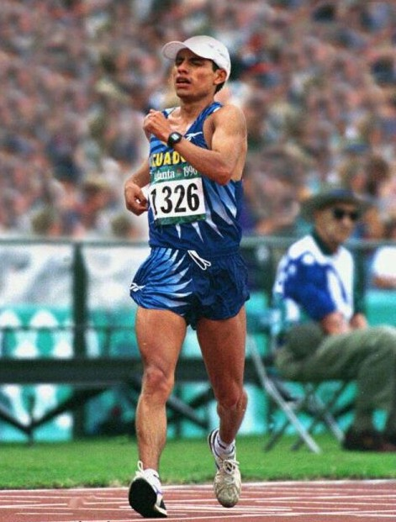
- Dion Russell AUS 1:30:04

Jefferson Perez becomes a national hero in Equador by winning their first ever Olympic gold.

Men 50km Walk

Garcia of Spain had won the 1993 World Championship in 3:41:41 ahead of Konnonen of Finland. Mercanario of Mexico had beaten Garcia and Sanchez to win the 1993 World Cup. Spitsyn of Russia had won the 1994 European Championship in 3:41:07. Konnonen of Finland won the 1995 World Championship in 3:43:42 ahead of Perricelli of Italy and Korzeniowski of Poland. Yongshen of China had beaten Garcia and Konnonen to win the 1995 World Cup in 3:41:20. There were just so many talented big time performers. Would it be Garcia or Konnonen or one of the Russians or Mexicans.

As it turned out, the Polish walker Korzeniowski, who had been disqualified when in second place at the 49 km mark of the 1992 Olympic 50 km even finally made his breakthrough in this most prestigious of events, after a series of top 5 finishes in most of the big events of the last 4 years. With this win, a superstar was born. 7 years later, Korzeniowski is still the top 50 km walker in the world but more of that later.

- Robert Korzeniowski POL 3:43:30
- Mikhail Shchennikov RUS 3:43.46
- Valentin Massana ESP 3:44.19
- Arturo Di Mezza ITA 3:44.52
- Viktor Ginko BEL 3:45.27
- Ignacio Zamudio MEX 3:46.07
- Valentin Konnonen FIN 3:47.40
- Sergey Korepanov KAZ 3:48.42
Duane Cousins AUS DNF
Simon Baker AUS DQ
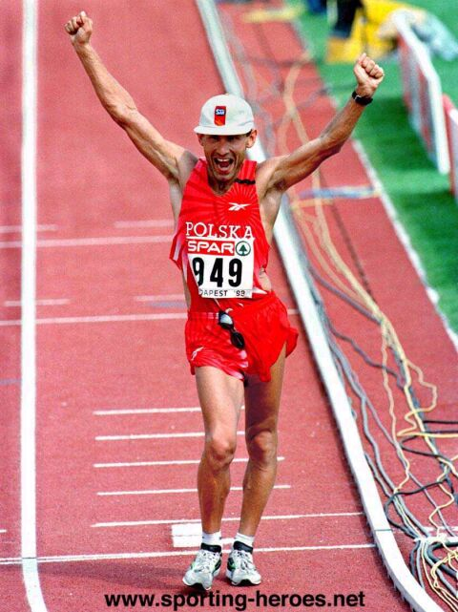

Korzenioski shows jubilation as he crosses the line as the ultimate of winners – an Olympic champion

And what of the large Australian contingent. I will not attempt to discuss all the walkers but will focus on the top performer, Nick A’hern, and the 3 Victorians.

Nick A’Hern produced the walk of his life to take fourth, only 8 seconds behind world record holder and third place getter Segura. It was the highest place finish since Noel Freeman in 1964 and was definitely Nick’s best ever international result.
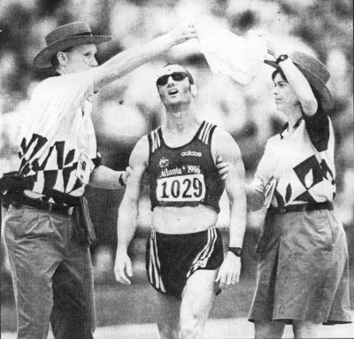

Nick A’hern crosses the finishing line. He said “What a cruel way to finish, but I gave it everything today”.

Dion Russell, just 21 years of age, had already represented Australia in two World Junior Championships and had broken Nick A’Hern’s various Australian Junior Records as he progressed up through the ranks. In 1994 he had gained an AIS scholarship and soon staged the first of his many battles with Nick for local supremacy. 1995 saw him make his first Racewalking World Cup appearance in Beijing (53rd in 1:28:25) in May followed by a World Student Games walk in Fukuoka (8th in 1:27:20) in September. This was followed by 2nd to Nick in the Olympic Games 20 km trial. Olympic selection was confirmed.

In April 1996, Dion headed off to Germany for his Olympic preparation. In April, he won the German National 20 km roadwalk title and raced impressively in a number of races. But his first Olympic walk was perhaps personally disappointing, in that he came 47th in 1:30:04. He needed further time to mature as a distance walker. That would come over the next 4 years.

Duane Cousins was another of the new young breed of walkers. A good junior, he had burst into senior ranks with a great first up 50 km time of 4:12:35 in December 1994 at only 21 years of age. His time gained him him a place in the Racewalking World Cup team, and in Beijing the following May, he came 71st in 4:31:28. He then placed 2nd in the Canberra 20 mile event in 2:29:24, won his first National 50 km Title in Adelaide in 4:15:20 in convincing style and then won the AFRWC 20 km race in Melbourne in 1:29:10. To cap the year off, he won a VRWC 50km walk in Melbourne in an astonishing 3:54:38. Duane had seemingly come from nowhere to produce a world ranking 50 km performance. He was immediately offered an AIS scholarship and relocated to Canberra in early 1996. He continued on his merry way with further great performances. He won the AV 50 km championship and Olympic trial in Melbourne in 3:56:1. June saw him repeat his 2nd place in the Canberra 20 Mile with an improved 2:24:24. Then he won his second national title, the Australian 30 km, in Sydney.

Alas, his Olympic walk in Atlanta is remembered in unique circumstances. He was directed back into the Olympic Stadium when he still had a lap of the 2 km course to complete. He crossed the line in a provisional 26th place but this was later amended to ‘DNF’. He had attempted to clarify the instructions at the time but, in a confused state, accepted the course marshal’s directions. He subsequently received an official written apology from the Atlanta Committee for the Olympic Games and an explanatory note was also attached to the official results. But it was poor consolation for Duane in his first Olympic venture.
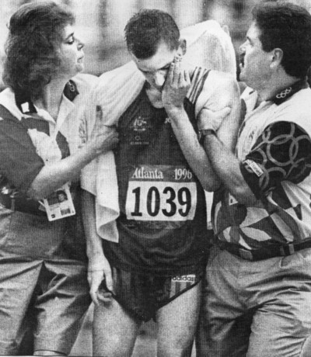
Duane gets assistance after finishing the 50 km incorrectly after being wrongly directed by an official.

Simon Baker had struggled for form since the 1992 Olympics. His last big international race as an AIS scholarship holder was the 1994 Commonwealth Games when he stuggled home for 6th place in 2:14:02. Later that same year, he resigned his AIS scholarship as an athlete and took up an assistant coaching position at the AIS. He still raced but not with the same fire as previously. His final throw of the dice was in 1996 when, at 38 years of age, he was selected for his fourth Olympic Games, this time in Atlanta. Unfortunately it was a disappointing meet for Simon - he was disqualified in the 50 km walk, only the second DQ in his long and illustrious international career. Since then, he has coached a number of our international walkers and has been a regular member of a number of high profile athletics commissions, both nationally and internationally.

2000 Sydney

As in 1996 the walking team consisted of 7 members and once again it was split between NSW with 4 competitors and Victoria with 3 competitors.

The team was very experienced. Saxby and A’Hern were in their third Games while Saville, Russell and Cousins were in their second Games. Only Lisa Sheradin-Paolini and Nathan Deakes were a first time Olympians.

Women 20km Walk

In 1999 the international distance for women was increased to 20 km and all of a sudden there were no clear favourites for the Sydney Olympics. A good 10 km walker does not necessarily make a great 20 km walker. With only a couple of international events to prepare, the Chinese showed early domination. Liu Hongyu and Wang Yan fiinished first and second in the 1999 World Championships (1:30:50 and 1:30:52) and then Liu improved her time to 1:27:32 to narrowly win the 1999 World Cup ahead of Fedoskina of Russian (1:27:35) with Wang in fifth place.

The inaugural Olympic 20 km event, raced in hot and humid conditions, was unfortunately marred by a series of controversial disqualifications at the front of the field.

The pace got quicker and quicker as, one by one, the main protagonists tried to break the others. By the 13 km mark, the pack was reduced to 5 walkers – the favourites Liu and Wang of China, Perrone of Italy, Saville of Australia and Platzer of Norway. Soon afterwards, Wang and Platzer dropped behind and Liu, Perrone and Saville were left on their own in front.

Eventually it was Liu who, at 16 km, got the critical break and opened up a lead of some 20-30 m. But no sooner had she made her break than she was disqualified and the lead returned to Saville and Perrone. Perrone looked the stronger of the 2 and eventually made her own decisive break at 17 km. But then she was disqualified and she walked off to the side of the track. She was then advised by Italian officials to rejoin the race, RAN to catch up to Saville and then walked for a further 2 km alongside her. Saville was visibly upset by this and repeatedly asked bystanders what was going on as she had seen Perrone removed from the course. It was almost certainly during this 2 km lap that Jane got her third red card. If so, it is a very unfair way to be put out. Perrone should not have been on the course and the officials were at fault for not inforcing her withdrawal. She eventually stopped at about the 19 km mark and Jane walked from then on, clearly in the lead, back to the stadium, thinking she had won. I cannot even begin to imagine her utter despair when told in the tunnel into the stadium that she had been disqualified.

Yet after the race, she explained to the press, "that pushing the boundaries of the sport (race walking) to its limit is part of the sport itself and I pushed it too far today." Her acceptance of the situation was very gallant and she is to be congratulated on her fine sportsmanship.
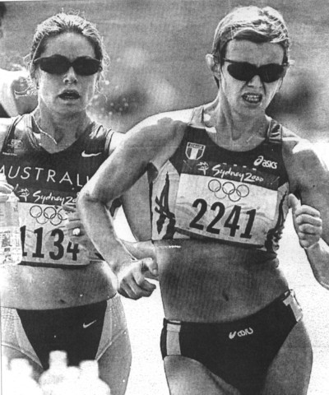

Saville and Perrone of Italy battle it out before their disqualifications

The official results show Wang taking the gold and Platzer taking the silver.

- Liping Wang CHN 1:29:05 OR
- Kjersti Platzer NOR 1:29:33
- Maria Vasco SPA 1:30:23
- Erica Alfridi ITA 1:31:25
- Maria Gomez MEX 1:31:33
- Norica Cimpean ROM 1:31:50
- Kerry Saxby-Junna AUS 1.32.02
- Tatyana Gudkova RUS 1:32:35
- Lisa Sheradin-Paolini AUS 1:40:57
Jane Saville AUS DQ

Men 20km Walk

Korzeniowski was running hot after his 1996 Olympic success. He quickly followed it up with a fine win in the 1996 European Cup 20 km in 1:21:46 ahead of Plaza of Spain and Vasquez of Mexico. This was followed by a win in the 50 km event in the 1997 World Championship in 3:44:46 ahead of Garcia of Spain and Rodriguez of Mexico. Thenext year he won the 1998 European Championship with 3:43:51 ahead of Konnonen of Finland and Plotnikov of Russia but then suffered a rare defeat in the 1998 European Cup 20 km (1:20:40) behind Fernandez of Spain who won in 1:20:31. He was then disqualified in the 1999 World Championship 50 km while in the leading group and was placed 4th in the 1999 World Cup (1:20:52) behind Seguare of Mexico, Guohui of China and Andreyev of Russia.

The question was now –which event would he choose for Sydney? He was amongst the best over both 20 km and 50 km but there were so many speedy walkers over the shorter distance. World record holder Segura of Mexico looked the best on paper and Perez, although quiet in the intervening 4 years, could not be discounted after his 1996 Olympic Victory.

The program was duly published and it showed Korzeniowski in both walks. The 20 km event was first and most interest duly centred on Korzeniowski and Segura. It turned out to be one of the most memorable Olympic events ever but for the wrong reasons.

Korzeniowski walked his race from the front and continually pressured the other walkers until, one by one, they fell away in the hot and sunny conditions. Eventually a group of 3 were left – Korzeniowski and the Mexicans Segura and Noe Hernandez. In the final kilometre, Segura made the decisive break and won by 2 seconds from Korzeniowski with Fernandez a further 4 seconds back.

It was not till 15 minutes after the event when Segura was disturbed during a television interview to be informed that he had been disqualified. He had received one warning early in the race. His second warning, of which he apparently was not aware, came as he left the 2 kilometer loop and began accelerating to catch the two leaders as they headed into the Olympic Stadium. His third and fatal call came just 400 meters before the end of the race.

Korzeniowski was then awarded the gold medal in a time of 1:18:59 (beating the previous best Olympic mark of 1:19.57 set by Czech Jozef Pribilinec in 1988 in Seoul) and Hernandez moved up from third to second.

Korzenioswki’s 2 km lap splits tell the story of his remarkably even pace (8:00, 7:57, 8:00, 7:58, 8:00, 7:58, 7:51, 7:44, 7:45, 7:52). His race tactic was obvious – start fast and then just get faster and faster!

- Robert Korzeniowski POL 1:18:59 OR
- Noe Hernandez MEX 1:19:03
- Vladimir Andreyev RUS 1:19:27
- Jefferson Perez ECU 1:20:18
- Andreas Erm GER 1:20:25
- Roman Rasskazov RUS 1:20:57
- Francisco Javier Fernan SPA 1:21:01
- Nathan Deakes AUS 1:21:03
- Nick A’Hern AUS 1:21:34
- Dion Russell AUS 1:25:26

Men 50km Walk

Korzeniowski had already been the favourite to retain his Olympic 50 km title but after his 20 km victory, he became a dead certainty in most people’s eyes. Garcia of Spain and Sanchez of Mexico seemed most likely to challenge.

An 8AM start did little to protect competitors from a hot day and, by 9AM, the temperature was nudging 30ºC and the sun beat down on an open course that offered the walkers little protection. Yet the pace was on from the start and a group of 10 walkers gradually asserted their superiority. And what a group it was – Robert Korzeniowski (POL), Valentin Kononen (FIN), Nicolay Matyukhin (RUS), Craig Barratt (NZ), Nathan Deakes (AUS), Jesus Garcia (ESP), Aigars Fadejevs (LAT) and all 3 Mexicans.

As the laps were gradaully ticked off, the pace quickened and, one by one, the group shrank as walkers dropped off. Eventually the leading group had dropped to 3 - Korzeniowski, Deakes and Sanchez. At 35 km, Nathan finally cracked and that left Korzeniowski and Sanchez who got quicker and quicker until eventually Sanchez cracked at just over 40 km. This left Korzeniowski to walk to the finish on his own. He slowed, showing the effects of his amazing race, but maintained a perfect style to the finish. His lap times (23:25, 22:28, 22:12, 21:55, 21:48, 21:42, 21:33, 21:25, 22:11, 23:43) showed a race in which the pace quickened for every 5 km split up 40 km.

He became the first walker to win the roadwalk double (20 km and 50 km at the same Olympics). That added to his gold medal in the 50 km at the 1996 Olympics makes him one of the greatest Olympic walkers of all time.

Latvia's Aigars Fadejevs was a surprise in winning the silver, 1.12 behind in 3:43.40. He had dropped off the lead group at about 30 km but had powered home as those in front had wavered. This came on top of his fine 14th place in the 20 km. Mexico's Joel Sanchez, the last walker to fight Korzeniowski for the race lead, took bronze in 3:44.36. He paid the penalty for trying to match Kozeniowski’s suicidal pace.

- Robert Korzeniowski POL 3:42:22
- Aigars Fadejevs LAT 3:43:40
- Joel Sanchez Guerrero MEX 3:44:36
- Valenti Massana SPA 3:46:01
- Nikolai Matioukhine RUS 3:46:37
- Nathan Deakes AUS 3:47:29
- Miguel Angel Rodriguez MEX 3:48:12
- Roman Magdziarczyk POL 3:48:17
- Dion Russell AUS 4:02:50
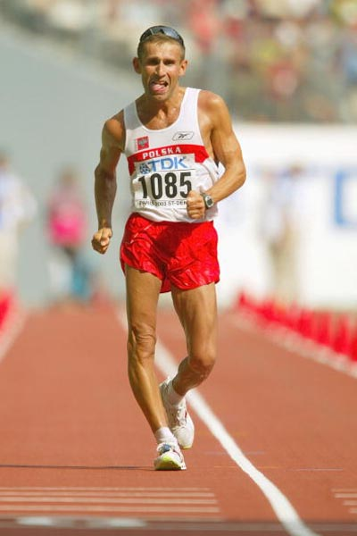
- Duane Cousins AUS 4:10:43

Korzekiowski in typical style – alone in the finish straight.
Again, a brief discussion of the Victorian competitors is in order.

Nathan Deakes, at 22 years of age, and a former World Junior bronze medallist, was always expected to do well. But who could have imagined just how well - his inaugural Olympic walks were wonderful. In the 20 km, he finished 8th in 1:21:03 and then in the 50 km (held in very hot conditions) he finished 6th in 3:47:29, a PB. What made his 50 km walk even more impressive was the way in which he aggressively walked. As Korzenowski applied the pressure and got faster and faster, only 2 walkers were able to stay with him – Nathan and Sanchez of Mexico. It was not till 35 km that Nathan finally cracked with Sanchez dropping off 5 km later. Nathan struggled home and dropped a few places, but gave notice that he was something special.

Nathan has since gone onto become one of the top walkers in the world with a Goodwill Games win and various high profile victories on the world stage.
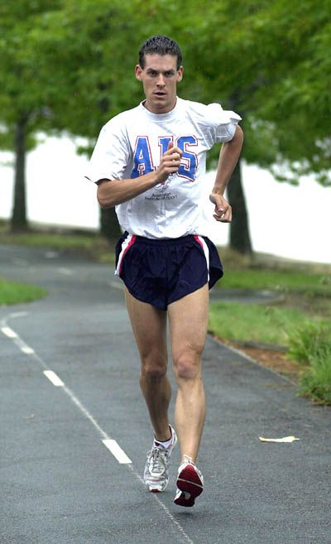

Nathan training on the biketracks of Canberra in 2002

Dion Russell had improved steadily since his initial 1996 Olympic appearance. He had also extended his range to include the 50 km distance and had won the 1997 and 1998 50km National titles, the 1998 win being in a PB time of 3:47:34. 1999 saw him finally defeat Nick A’Hern on his own terms when he won the National 20 km road title in 80:49 (Nick was 2nd in 81:18). In August he finished 13th in the IAAF World Championships in Seville. The time of 3:59:23 was very good considering the hot conditions. Coming back to Australia, he put in a further 3 months of hard work in Canberra before fronting for the Australian 50 km title race in Melbourne. This was also the Olympic 50 km selection trial. In that race, he and Nathan Deakes walked together the whole way and crossed the line for equal 1st in 3:52:33 – it was a performance that was really only a training walk and neither competitor raised more than a puff of effort.

But, unknown to most, Dion had decided by the end of 1999 that it was time to move on from a full time walking career – there were other priorities that he had to honour. The Sydney Olympics would be his last international event. He continued with his walking preparation but, in terms of training mileage, the 6 months leading up to the Olympics were perhaps the leanest within the preceding 18 months. In Sydney he came 25th in the 20 km in 1:25:26 and 27th in the 50 km in 4:02:50. This was followed by the surprise public announcement that he was retiring from the sport. He resigned his AIS scholarship and moved on.

His Sydney performances must be seen in this light and his comment below puts walking as a sport into its proper perspective. It is after all only a sport and it is to be savoured while it can. Eventually other more important priorities emerge and people must make tough decisions.

At the end of the day, I was in fact very happy with my results in Sydney, even if others had different expectations and were subsequently disappointed.

It is to Dion’s credit that he could make such a decision while he was still at the top of the sport. In retrospect, his times put him amongst our best ever 20 km and 50 km exponents and his 10 year racewalking career leaves no doubt as to his talent and competitiveness.

Duane Cousins, like Dion, also continued on after his 1996 Olympic appearance and won silver in the 1998 Commonwealth Games in 1998. But in a surprise move, he resigned his AIS scholarship in April 1999 and returned to his native Bendigo. Without the resources of the AIS to nurture his walking and with a full time job, he still managed 3rd in the 50 km Olympic Games Trial in December 1999 and his time of 3:59:34 was good enough to guarantee selection. His Olympic walk in Sydney was tough and, in the hot conditions, he could only manage 34th in a slow (by his high standards) time of 4:10:43.

Since then form his home base in Bendigo, he has continued to produce sub 4 hour 50 km performances on a regular basis and remians one of our top distance exponents.

THE VICTORIAN ROLL OF HONOUR

The following Roll of Honour includes all Olympic Representatives who were resident in Victoria and/or members of the Victorian Race Walking Club at the time of their selection.

1912 Stockholm William Murray 10,000m DQ in heat

1948 London George Knott 10,000m 6th in heat

1956 Melbourne Don Keane 20 km 6th 1:33.52
1956 Melbourne Tedd Allsopp 20 km 10th 1:35:43
1956 Melbourne Ray Smith 50 km 6th 4:56:08
1956 Melbourne Tedd Allsopp 50 km DQ
1956 Melbourne Norm Read 50 km 1st 4:30:42 (NZ rep but mbr of VAWC)
1960 Rome Noel Freeman 20 km 2nd 1:34:16
1960 Rome Noel Freeman 50 km DQ

1964 Tokyo Noel Freeman 20 km 4th 1:32:06
1964 Tokyo Bob Gardiner 20 km DNF
1964 Tokyo Bob Gardiner 50 km 5th 4:17:06
1964 Tokyo Ted Allsopp 50 km 17th 4:31:07

1968 Mexico Bob Gardiner 50 km 19th 4:52:29

1972 Munich Bob Gardiner 20/50 km withdrew injured

1976 Montreal Ross Hayward 20 km 12th 1:30:59

1980 Moscow David Smith 20 km DQ
1980 Moscow David Smith 50 km DNF
1980 Moscow Willi Sawall 50 km 8th 4:08:25
1984 Los Angeles David Smith 20 km 10th 1:26:48
1984 Los Angeles Simon Baker 20 km 14th 1:27:43
1984 Los Angeles Willi Sawall 20 km 16th 1:28:24
1984 Los Angeles Willi Sawall 50 km DNF
1984 Los Angeles Michael Harvey 50 km 11th 4:09:18
1984 Los Angeles Andrew Jachno 50 km DNF
1988 Seoul Simon Baker 20 km 11th 1:21:47
1988 Seoul Andrew Jachno 20 km 28th 1:24:50
1988 Seoul Simon Baker 50 km 6th 3:44:07
1988 Seoul Andrew Jachno 50 km 19th 3:53:33
1992 Barcelona Gabrielle Blythe 10 km 31st 50:13
1992 Barcelona Andrew Jachno 20 km 31st 1:36:49
1992 Barcelona Simon Baker 50 km 19th 4:08:11
1996 Atlanta Dion Russell 20 km 47th 1:30:04
1996 Atlanta Duane Cousins 50 km DNF (due to official miscount of laps)
1996 Atlanta Simon Baker 50 km DQ

2000 Sydney Dion Russell 20 km 25th 1:25:26
2000 Sydney Dion Russell 50 km 27th 4:02:50
2000 Sydney Duane Cousins 50 km 34th 4:10:43
2000 Sydney Nathan Deakes 50 km 6th 3:47:29

OLYMPIC STATISTICS

The Olympics walks are not numerically large events compared with other carnivals such as the Racewalking World Cup or the European Championships. The tough Olympic qualifying standard ensures that only the cream of the sport participate.

The participating rate has risen gradually over the years and the last 2 Olympics have seen the highest numbers of competitors so far in the walks. We can expect to see in excess of 60 competitors per event in 2004.

The number of disqualifications per event has fluctuated over the years. In the early days of track walking, the rate was high and this led to the inevitable removal of these events from the Olympic theatre. As distances were increased, the 1960s and 1970s saw low disqualification rates but, with the increasing speed of the competitors in recent years, the disqualification rate has risen again. It now averages slightly less than 10% of the field and seems to have levelled off.

Year Event Number of Competitors DNF DQ %DQ

1906 1500m walk 9 0 2
3000m walk 8 0 3
1908 3500m walk 24 2 2 8
10000m walk 25 10 0 0
1912 10000m walk 22 3 3 14
1920 3000m walk 22 0 2 9
10000m walk 23 3 7 30
1924 10000m walk 23 0 4 17
1932 50 km walk 15 5 0 0
1936 50 km walk 33 6 1 3
1948 10000m walk 23 3 7 30
50 km walk 21 5 0 0
1952 10000m walk 23 0 5 21
50 km walk 31 3 0 0
1956 20 km walk 21 0 4 19
50 km walk 21 6 2 9
1960 20 km walk 36 1 7 19
50 km walk 39 5 6 15
1964 20 km walk 30 2 2 6
50 km walk 34 2 1 3
1968 20 km walk 33 3 1 3
50 km walk 46 7 1 2
1972 20 km walk 24 1 1 4
50 km walk 36 5 2 5
1976 20 km walk 38 1 1 3
1980 20 km walk 34 2 7 20
50 km walk 27 8 4 15
1984 20 km walk 38 0 0 0
50 km walk 31 5 9 29
1988 20 km walk 53 1 3 6
50 km walk 42 3 4 10
1992 10 km walk women 44 0 6 14
20 km walk men 42 5 3 7
50 km walk men 42 3 7 17
1996 10 km walk women 44 1 5 11
20 km walk men 58 1 4 7
50 km walk men 51 9 6 12
2000 20 km walk women 57 7 5 9
20 km walk men 47 1 2 4
50 km walk men 56 9 8 14

REFERENCES

A Brief History of Racewalking by Robert G. Osterhoudt, University of Minnesota, 1975

The Sport of Race Walking by the Race Walking Association, Middlessex, 1962

100 Years of Racwalking by Sandro Damilano, 2002

Race Walking by Martin rodow, World Publications, California, 1975

Vladimir Golubnichy by Ye. Bogatyryov, Progress Publishers, 1979

The Official Centenary History of the A.A.A. by Peter Lovesey, A.A.A, London, 1979

The Complete Book of the Olympics by David Wallechinsky, Penguin Books, New York, 1996

The History of the Olympics by Martin Tyler and Phil Soar, Marshall Cavendish Books Ltd, London, 1980

